**Assistant Secretary of the Air Force**

**for Acquisition, Technology, and Logistics**



**Fiscal Year (FY) 2022**

**Continuous Process Improvement and Innovation (CPI2) Report**

**Reporting Period**

**1 October 2021 to 30 September 2022**

Version 1

30 September 2022

This page intentionally left blank.

03 October 2022

MEMORANDUM FOR SAF/AQ

FROM: ACQUISITION CHIEF PROCESS OFFICER (CPO)

SUBJECT: Fiscal Year (FY) 2022 Air Force Continuous Process Improvement (CPI) Report

References: (a) HAF MD 1-10, 02 Sep 16, *Assistant Secretary of the Air Force (Acquisition)*

(b) Master Process Officer Appointment Memorandum Delegation of Acquisition Chief Process Officer and Value Engineering Senior Management Official to SAF/AQXP Deputy Director, 21 Jan 2020

1. The Assistant Secretary of the Air Force (Acquisition) CPI2 Plan for FY22 was focused on enterprise-driven, process-based, results-oriented themes for solving problems, executing smart business decisions, reducing acquisition cycle time, and increasing process outcomes. The goal of the plan was to assist the acquisition enterprise in becoming more effective and efficient in acquisition execution.
2. The FY22 CPI Report covers accomplishments across two focus areas:
   1. CPI Execution/Support: Facilitated six CPI events to enable Air Force improvements in support of the SecAF’s Management Initiatives. Identified improvement opportunities across the entirety of the Big “A” Acquisition processes (AQC Board of Directors Meeting, AQX Priorities, Acquisition Intel for Supply Chain Risk Management, DAF Acquisition Diversity and Inclusion Advisory Group, and Acquisition Leadership Seminar).
   2. APM: Consistent with SAF/AQ direction to institutionalize the APM, the CPI2 team expanded both the content, functionality, and currency of the model. In FY22, the CPI2 team held 47 APM training sessions with 411 people attending. In addition, the CPI2 team revised processes to reflect 71 added/changed reference documents in FY22.
3. My POC for any questions about this report is Mr. Brad Ferguson ([brad.ferguson.2@us.af.mil](mailto:brad.ferguson.2@us.af.mil)), Chief, CPI2 Branch.

MILDRED E. BONILLA-LUCIA, NH-IV

Acquisition Chief Process Officer

Table of Contents

CPI2 Execution 3

Acquisition Process Model (APM) 17

APM Training 17

APM Working Group (APMWG) 19

APM Update Summaries 20

APM NOTAMS Published 22

APM Landing Page 23

Value Engineering 23

2022 AF Value Engineering (VE) Plan 23

Value Engineering Management Advisory Group (VMAG) Participation 23

Policy/Guidance Analysis 23

Document Review 23

Other Support: 25

SAF/AQX SharePoint Management 25

Agile Transformation 26

Appendix A. APM Update Logs 26

# CPI2 Execution

In FY22, the CPI2 Branch expanded on its success of facilitating/helping in six CPI2 events. During these events, the branch trained over 326 people in various CPI2 tools and techniques. Click on any of the events below to see summaries on each event.

**Events Facilitated in FY22**

|  |  |  |  |
| --- | --- | --- | --- |
| Events | Dates | Champion(s) | Status |
| First Quarter |  |  |  |
| AQC Board of Directors Meeting | Nov 21 | Maj Gen Holt (SAF/AQC) | Completed – monitoring for implementation results. |
| Second Quarter |  |  |  |
| AQX Priorities | Dec-Mar 21 | Mr. Bailey (SAF/AQX) | Completed – expanding to enable line of sight goals. |
| Acq Intel SCRM Support for Digital Engineering – Current State | Feb 22 | Ms. Mazur (HAF/A2/6), Mr. Bailey (SAF/AQX) | Completed – results provided input for the future state event. |
| Acq Intel SCRM Support for Digital Engineering - Future State Characteristics | Mar 22 | Ms. Mazur (HAF/A2/6), Mr. Bailey (SAF/AQX) | Completed – monitoring for implementation results. |
| Third Quarter |  |  |  |
| DAF Acq Diversity & Inclusion Advisory Group (DIAG) | Jun 22 | Ms. Costello (SAF/AQ) | Completed – monitoring for implementation results. |
| Acquisition Leadership Seminar (ALS) | Jun 22 | Mr. Bailey (SAF/AQX) | Completed – monitoring for implementation results. |

**Strategic Alignment of CPI Efforts**

**Alignment with SecAF Management Initiatives and AQX Priorities**



|  |  |  |  |  |
| --- | --- | --- | --- | --- |
|  |  |  |  |  |

**1. AQC Board of Directors Meeting:** (3-5 Nov 21)

**Purpose:**

For the fourth consecutive year, provide facilitation and documentation support for identifying adjustments to the Objectives and Key Results ([OKR](https://en.wikipedia.org/wiki/OKR)) in the Air Force Contracting Flight Plan.

**Background:**

As the lead for Department of the Air Force Contracting, Maj Gen Cameron Holt directs the annual review and revision of the Air Force Contracting Flight Plan. Specifically, Maj Gen Holt desires Contracting Board of Directors input for creating the direction for the future year by considering prior year achievement.

**Participating Organizations (89 participants):**

AFLCMC/PK, SAF/AQC, AFMC/PK, AFDW/PK, AFICC/KM, AFSC Hill/PK, AFICC/CA, AFRL/PK, AFSC/PK, AFICC/CC, AFICC/KC, AFICC/KH, AFICC/KU, AFICC/KS, AFTC/PK, AFNWC/PZ, AFGSC/AFICC/KG, AFICA/KO, SSC/AC PK, SAF/GCQ

**Problem Statement:**

Because of both the progress made and the changes experienced in CY21, the Objectives and Key Results from the CY21 Air Force Contracting Flight Plan are not appropriate for CY22

**Applied CPI2 Tools/Techniques:**

Combined In-Person/Virtual Facilitation, Consensus Voting, Real Time Documentation

**Activities & Expected Results/Benefits:**

The team: 1) reviewed the achievements from executing the CY21 Contracting Flight Plan, 2) refined the Objectives for CY22 to address carry over Objectives from CY21 and new Objectives, 3) reviewed, refined, and closed applicable Key Results from CY21, and 4) developed new Key Results for CY22 to address the Line of Efforts and Objectives.

Benefits realized from the CY21 Contracting Flight Plan include the following:

1. Convert Air Force Federal Acquisition Regulation Supplement Procedures, Guidance, and Information (AFFARS PGIs) to Tactics, Tools, and Procedures (TTPs) (eliminated all AFFARS PGIs – 41 converted to TTPs and 41 eliminated entirely).
2. Reduce barriers to entry to work with the Air Force (added 1100 vendors who had not previously done business with the Air Force).

Highlights of the CY22 Contracting Flight Plan include the following:

1. Pursue the Free Cash Flow incentive – intended to enable more flexible funding among all funding categories – aligns with SecAF Management Initiative #7 and AQX Data and PPBE priorities.
2. Leverage Education with Industry (EWI) to identify new opportunities for acquisition improvement – align EWI more closely with current priorities – aligns with SecAF Management Initiative #1 and AQX Industrial and Workplace priorities.
3. Develop Supply Chain Risk Management contract language – reduce Supply Chain Risk for acquisition programs – aligns with SecAF Management Initiative #1 and AQX Bureaucracy and Industrial priorities.

**Follow-On Actions:**

Using the Flight Plan Dashboard on Contracting Central, the CPI2 team will monitor the results from this year’s initiatives. The resulting CY22 Flight Plan Dashboard is available at <https://www.afcontracting.hq.af.mil/loe/index.cfm> (CAC required).

**Event Artifacts:**

|  |  |  |  |  |
| --- | --- | --- | --- | --- |
|  |  |  |  |  |

|  |
| --- |
|  |

**2. AQX Priorities:** (multiple meetings throughout Dec 21 - Mar 22)

**Purpose:**

Translate the four AQX priorities by identifying the customer of the priorities and his/her drivers and performance expectations for successful achievement through aligned division goals.

**Background:**

Annually, AQX establishes overarching directorate priorities for the year consistent with higher level direction. These priorities provide a foundation for the development of division, branch, and individual goals.

**Participating Organizations (21 attendees across all meetings):**

SAF/AQX, SAF/AQXE, SAF/AQXP, SAF/AQXS

**Problem Statement:**

The SAF/AQX workforce lacks a common understanding of the expectations and commensurate definition of success to address the four SAF/AQX priorities.

**Applied CPI2 Tools/Techniques:**

CtQ Tree, Virtual/In Person Facilitation, Brainstorming, Real Time Documentation, Cascading Performance Measurement.

**Activities & Expected Results/Benefits:**

Through a series of meetings, the CPI2 team led the following activities:

1. Translation of the four SAF/AQX priorities into expected results (Voice of the Customer) with associated performance expectations.
2. Mapping of the performance expectations to the division/branch goals.

The translation of the priorities into expected results (with the commensurate cascading into division/branch/individual goals) should enable focused achievement of the priorities in FY22.

The AQX priorities (and the associated achievement of the performance expectations) align to SecAF Management Initiatives # 1 and 2.

**Follow-On Actions:**

In addition to the expected assessment of directorate/division/branch/individual goals against the priorities, the CPI2 team projects the use of the priorities (or their successors) for the establishment of FY23 directorate/division/branch/individual goals relative to the priorities.

**Event Artifacts:**

|  |  |  |  |  |
| --- | --- | --- | --- | --- |
|  |  |  |  |  |

|  |
| --- |
|  |

**3. Acq Intel Supply Chain Risk Management Support for Digital Engineering - Current State:** (Feb 22)

**Purpose:**

Develop the current state process to provide a common understanding of the starting place for addressing the challenges of informing acquisition programs with appropriate Supply Chain Risk Management (SCRM) related intel.

**Background:**

In September 2021, AF/A2 sponsored an overarching kickoff session to improve the infusion of acquisition intelligence into acquisition programs leveraging digital engineering. One of the outcomes of this session was the prioritization of improving the process for providing intel to support SCRM.

**Participating Organizations (23 participants):**

AFMC/A2X, AFLCMC/HNI. AFLCMC/INH, AFNWC/NXI, AFOSI/ICON, SAF/AQR, AFLCMC/HN, AFLCMC/INB, AFGSC/A2RA, AFLCMC/LZS, AFLCMC/21st IS, AFMC 178th ISRG/A2F, AFSC/IN, AFLCMC/HNC/TSN, AFMC/A4RM

**Problem Statement:**

The Materiel Intelligence Enterprise (MIE) does not satisfactorily or effectively understand roles, processes, and deliverables SCRM support of acquisition programs.

**Applied CPI2 Tools/Techniques:**

Process Mapping, SIPOC, CtQ Tree, Carousel Brainstorming, Real Time Documentation, Virtual Facilitation

**Activities & Expected Results/Benefits:**

The team developed the current state process model, associated SIPOC, and measures of success (both from an overarching and organizational approach) to establish a common understanding of the current state. Additionally, the team identified an initial set of 12 potential improvement opportunities.

For benefits from this event, the current state common understanding provided the basis for the subsequent future state event.

Addressing the SCRM aspect of acquisition programs aligns with the following:

1. SecAF Management Initiative #1 through improved program execution, improved communication and understanding of competitor activities, and improved insights on needed systems.
2. AQX Data priority through improved information dissemination.
3. AQX Industrial priority through improved insights on the impact of the industrial base support to acquisition programs.
4. AQX Workplace priority through improved teamwork among personnel involvement in the overarching process.

Additionally, the CPI2 team provided mentoring support for a Black Belt candidate – Maj Christina Hayhurst (AFLCMC/21 IS).

**Follow-On Actions:**

The CPI2 team conducted a Mar event to develop a plan of action for the future state.

**Event Artifacts:**

|  |  |  |  |  |
| --- | --- | --- | --- | --- |
|  |  |  |  |  |

|  |
| --- |
|  |

**4. Acq Intel Supply Chain Risk Management Support for Digital Engineering – Future State Characteristics:** (Mar 22)

**Purpose:**

Identify future state characteristics and develop commensurate recommendations to address the challenges of informing acquisition programs with appropriate Supply Chain Risk Management (SCRM) related intel.

**Background:**

In September 2021, AF/A2 sponsored an overarching kickoff session to improve the infusion of acquisition intelligence into acquisition programs leveraging digital engineering. One of the outcomes of this session was the prioritization of improving the process for providing intel to support SCRM.

**Participating Organizations (26 participants):**

AFMC/A2X, AFLCMC/HNI. AFLCMC/INH, AFNWC/NXI, AFOSI/ICON, SAF/AQR, AFLCMC/HN, AFLCMC/INB, AFGSC/A2RA, AFLCMC/LZS, AFLCMC/21st IS, AFMC 178th ISRG/A2F, AFSC/IN, AFLCMC/HNC/TSN, AFMC/A4RM

**Problem Statement:**

The Materiel Intelligence Enterprise (MIE) does not satisfactorily or effectively understand roles, processes, and deliverables for Supply Chain Risk Management (SCRM) support of acquisition programs.

**Applied CPI2 Tools/Techniques:**

Carousel Brainstorming, Real Time Documentation, Virtual Facilitation, Ideal State, Value Analysis, Multivoting (N/3), Affinitization

**Activities & Expected Results/Benefits:**

The team conducted a current state value analysis, identified ideal state characteristics, expanded the list of potential improvement opportunities to include 17 ideas, and developed a draft POA&M on 12 ideas. The team recommended addressing the following:

-- Establish and disseminate SCRM roles and responsibilities

-- Establish a common publication platform for MIE products relative to SCRM support

-- Enhance collaboration throughout the process – the team identified a pilot opportunity with the Rapid Sustainment Office (RSO Pilot)

-- Expand the traditional counter intel approach to include foreign intel in the SCRM support process

-- Involve the Directors of Intelligence (DoIs) and Acquisition Intelligence Analysts (AIAs) in the SCRM documentation process

-- Address gaps and seams within the process.

The expected benefit from the above recommendations is reduced supply chain risk in the execution of acquisition programs as enabled through a combination of improved tools, enhanced communication, and established processes.

Addressing the SCRM aspect of acquisition programs aligns with the following:

1. Management Initiative #1 through improved program execution, improved communication and understanding on competitor activities, and improved insights on needed systems.
2. AQX Data priority through improved information dissemination.
3. AQX Industrial priority through improved insights on the impact of the industrial base support to acquisition programs.
4. AQX Workplace priority through improved teamwork among personnel involvement in the overarching process.

**Follow-On Actions:**

In addition to monitoring the execution of the recommendation, the CPI2 team projects the following actions through the remainder of FY22.

1. Review and approval of the recommendations from the Mar event.
2. Identification of integration points with other ongoing related CPI2 efforts.
3. Conduct additional event to develop future state.

**Event Artifacts:**

|  |  |  |  |  |
| --- | --- | --- | --- | --- |
|  |  |  |  |  |

|  |
| --- |
|  |

**5. DAF Acq Diversity & Inclusion Advisory Group (DIAG):** (1-3 June 22)

**Purpose:**

Strategic planning to identify and prioritize actionable initiatives to strengthen the acquisition workforce and manage talent through Diversity, Equity, Inclusion, and Accessibility (DEI&A) implementation, i.e., “move the needle.”

* Strategic influence from SAF/AQ, enabling the field by leveraging support from the Champions
* Tactical actions for SAF/AQ personnel (and SAF/SQ as needed)
* Mechanisms to capture, measure, track, and report issues

Reinvigorate the DIAG team and identify resources required to accomplish the mission and vision.

Align relationships w/ key stakeholders, especially SAF/DI, SAF/SQ, MAJCOMs, FIELDCOMs, and other DEI&A-focused teams.

**Participating Organizations (20 participants; 3 guest speakers):**

AFDW 11 CONS, AFNWC/ND (2), AFPEO/CM, AFRL/RW, SAF/AQ (2), SAF/AQC, SAF/AQH (2), SAF/AQR (4), SAF/AQX (4), SAF/GCQ, SAF/SA

**Problem Statement:**

The Air Force suffers from barriers to entry and promotion for all - regardless of race, ethnicity, gender, or sexual orientation. Such barriers hinder military superiority.

**Applied CPI2 Tools/Techniques:**

Brainstorming, Real Time Documentation, Scoping Terminology (JDI, Event, Project),

7-Block Template

**Activities & Expected Results/Benefits:**

* Champions (AQ, AQR, SA) and Executive Director (AQH) reinforced support
* Steering Committee reviewed/discussed DIAG charter, prior work, and potential gaps/blind spots
* Guest speakers presented best practices/lessons learned
  + Black/African American Employment Strategy Team (BEST)
  + Guardian & Airman Innovation Network (GAIN) – SAF/MGB
* Steering Committee drafted plans for the upcoming year
  + Identified/characterized initiatives and action items
  + Revisited Vision/Mission statements
  + Determined next steps
* Support the implementation of Management Initiative #10

**Follow-On Actions:**

* The Steering committee requested AQ CPI2 team's services to facilitate weekly meetings thru the out-brief to SAF/AQ. The CPI2 team assisted with refining the briefing and explained the strategic-planning methodology and CPI terms employed.
* The Steering Committee will update the DIAG charter to reflect approved changes.

**Event Artifacts:**

|  |  |  |  |  |
| --- | --- | --- | --- | --- |
|  |  | As of 21 Jun 2022 | As of 22 Sep 2022 |  |

|  |
| --- |
|  |

**6. Acquisition Leadership Seminar (ALS):** (8-9 June 22)

**Purpose:**

Provide facilitation/moderation for the following four workshops at the ALS: Digital Engineering, Artificial Intelligence, Rapid Sustainment Office, and Tech Transition.

**Background:**

The intent to the ALS was to provide a forum for mid-level acquisition professionals from across the acquisition enterprise to both engage/dialogue with senior Department of the Air Force leaders and participate in interactive breakout sessions.

**Participating Organizations (147 attendees; 8 presenters):**

Program Office personnel from across the DAF.

**Problem Statement:**

Workshops without facilitation/moderation often lose focus.

**Applied CPI2 Tools/Techniques:**

Facilitation

**Activities & Expected Results/Benefits:**

* Conducted each of the four workshops twice.
  + Provide knowledge transfer in support of Management Initiatives #3, 5, and 7
* Identified opportunities to amplify the workshop messages.
  + Provide Management Initiatives overview.
    - Specific focus on Management Initiative #7
    - Provide process understanding
  + Provide lessons learned/examples relative to workshop topics.
    - Good examples provided for application of Digital Engineering principles
    - Interest in more information regarding tools and capabilities for Digital Engineering infusion in programs
* Received letters of commendation for our support in facilitating/moderating the workshops
  + SAF/AQX leadership indicated the sessions were “instrumental in making the ALS a rousing success.”

**Follow-On Actions:**

* Review feedback from the attendees to identify additional actions.

**Event Artifacts:**

|  |  |  |  |  |
| --- | --- | --- | --- | --- |
|  |  |  |  |  |

|  |
| --- |
|  |

**CPI Tools Training Matrix**

The CPI2 branch provides Just-In-Time training to event attendees on various CPI tools. For the events conducted in FY22, the below table shows the number of attendees trained by tool.

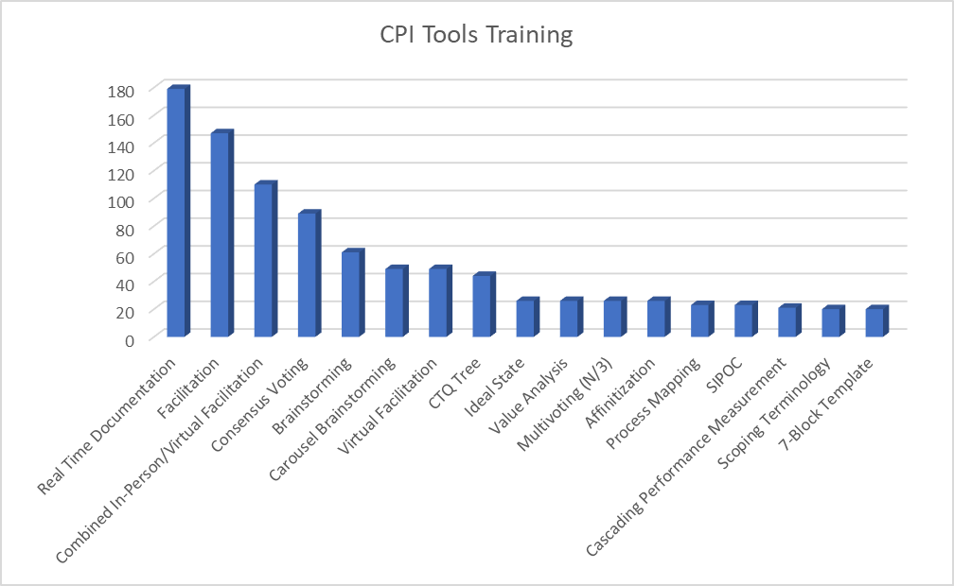

**Upcoming Events in FY23**

Additionally, the CPI2 branch has begun work on the following efforts and anticipates completion during FY23:

**1. DAF Contracting Roles & Responsibilities:** (TBD in 23)

**Purpose:**

Develop implementation and communication strategies for recent changes in contracting due to the stand-up of Space Force.

**Background:**

Planning for the standup of the support staff for the Space Service Acquisition Executive assumed SAF/AQC would provide contracting support. However, impacted organizations have conflicting positions on contracting roles and responsibilities.

**Participating Organizations (TBD participants):**

SAF/AQC, SAF/SQX, SSC/PK, SDA, AFICC/KS, SAF/GCQ, Space RCO, DAF RCO, AFMC/PK, AFPEO/CM

**Problem Statement:**

Several strategic decisions have been codified in the HAF MD 1-10 (AQ) and HAF MD 1-17 (SQ). To eliminate confusion and misunderstanding within the contracting workforce, contracting leadership believes it is critical that an implementation and communication strategy is developed for execution.

**Applied CPI2 Tools/Techniques:**

TBD

**Activities & Expected Results/Benefits:**

TBD

**Follow-On Actions:**

TBD

**Event Artifacts:**

|  |  |  |  |  |
| --- | --- | --- | --- | --- |
|  |  |  |  |  |

|  |
| --- |
|  |

**2. Acq Intel Supply Chain Risk Management Support for Digital Engineering – Future State Process:** (TBD in 23)

**Purpose:**

Build upon the prior two events to develop a future state process and commensurate recommendations to address the challenges of informing acquisition programs with appropriate Supply Chain Risk Management (SCRM) related intel.

**Background:**

In September 2021, AF/A2 sponsored an overarching kickoff session to improve the infusion of acquisition intelligence into acquisition programs leveraging digital engineering. One of the outcomes of this session was the prioritization of improving the process for providing intel to support SCRM.

**Participating Organizations (TBD participants):**

AFMC/A2X, AFLCMC/HNI. AFLCMC/INH, AFNWC/NXI, AFOSI/ICON, SAF/AQR, AFLCMC/HN, AFLCMC/INB, AFGSC/A2RA, AFLCMC/LZS, AFLCMC/21st IS, AFMC 178th ISRG/A2F, AFSC/IN, AFLCMC/HNC/TSN, AFMC/A4RM

**Problem Statement:**

The Materiel Intelligence Enterprise (MIE) does not satisfactorily or effectively understand roles, processes, and deliverables for Supply Chain Risk Management (SCRM) support of acquisition programs.

**Applied CPI2 Tools/Techniques:**

TBD

**Activities & Expected Results/Benefits:**

TBD.

**Tabled Events in FY22**

Additionally, the CPI2 branch has begun work on the following efforts and awaits direction from the relevant champions/team leads for event execution:

**1. AFRL/XP Strategy to Execution Process:** (TBD)

**Purpose:**

AFRL executes a $3B budget/300+ programs across a span of disciplines at various levels of maturity (6.1. 6.2. 6.3 6.4). To do this efficiently the enterprise needs to organize, prioritize, and allocate resourcing according to strategic direction and user demand signals…all of which can change based on the current threat environment.

**Participating Organizations (TBD participants):**

AFRL/XP (Directorate and Division Leads)

**Problem Statement:**

Misaligned timelines, deficient messaging, slow execution, and a general enterprise confusion of staff level processes have driven inefficiencies within the AFRL organization.

**Applied CPI2 Tools/Techniques:**

TBD – likely tools/techniques include Current/Future State Process Map, Real Time Documentation, Carousel Brainstorming, Is/Is Not, CtQ Tree

**Activities & Expected Results/Benefits:**

TBD

**Follow-On Actions:**

TBD

**Event Artifacts:**

|  |  |  |  |  |
| --- | --- | --- | --- | --- |
|  |  |  |  |  |

|  |
| --- |
|  |

**2. Free Cash Flow:** (TBD)

**Purpose:**

Identify and implement options for enabling more flexible funding of DAF programs.

**Participating Organizations (TBD participants):**

SAF/AQC, SAF/AFPEO, AFLCMC/WVSS, SAF/AQH, SAF/AQC, SAF/AQRM, SAF/AQX

**Problem Statement:**

Current resource allocation process creates short-term incentives that drive behaviors inconsistent with building long-term military readiness and lethality. Inflexible PPBE process, virtually unchanged since its inception in 1961, is the key obstacle to rapidly shifting resources to respond to innovation-driven threats.

**Applied CPI2 Tools/Techniques:**

TBD – likely tools/techniques include Ideal State, Current/Future State Process Map, Failure Modes and Effects Analysis, PICK Chart, Brainstorming

**Activities & Expected Results/Benefits:**

TBD

**Follow-On Actions:**

TBD

**Event Artifacts:**

|  |  |  |  |  |
| --- | --- | --- | --- | --- |
|  |  |  |  |  |

|  |
| --- |
|  |

# Acquisition Process Model (APM)

## APM Training

The CPI2 branch offers two types of APM training. Familiarization training provides an overview of the model from both a content and functionality perspective. Recommended for anyone involved in any phase within any of the pathways within the Adaptive Acquisition Framework, the familiarization training provides a 60-minute interactive forum to present all the following: overview of authoritative documents governing the process information, explanation of the components and metadata composing the APM, and navigation capabilities within the APM. Conducted as a 30-minute interactive work session, update training provides a detailed look at recent changes and impacts to the model based on recently published documents. In addition, AFIT includes the APM as part of its FAM104 training which provides a quick overview of the content and capabilities of the model.

Highlights of training within FY22 include the following:

1. In response to a request from AFIT to expand the APM discussion within FAM104, the CPI2 team prepare a separate training module (a 15-minute video) covering the basics of the APM. In addition to the video, the CPI2 team prepared a companion multiple choice quiz to validate learning objectives. This video will serve as an initial example for other reusable training offerings.
2. In response to the retirement of the Defense Acquisition Guidebook in September, the CPI2 team received over 150 responses from APM trainees to provide recommendations for the priority of including the replacement guidebooks.
3. The CPI2 team continued to incorporate questions with the monthly APM Familiarization training invites to gather additional “voice of the customer”. Responses from the trainees served as reinforcements for including the Services pathway in the APM.
4. In response to requests from training attendees, the CPI2 team incorporated the legend on all diagrams to explain process classification within the APM (governing/core/enabling).

|  |  |  |
| --- | --- | --- |
|  | **FY22 APM Training**  [http://training.afacpo.com](http://training.afacpo.com/) | |
| **Sessions** | **Personnel** |
| **Completed** | **FYTD** |
| **APM Familiarization Training** | **30** | **347** |
| **APM Update Training** | **17** | **64** |
| **AFIT FAM104 (APM Overview)** | **22** | **581** |
| **Total** | **69** | **992** |

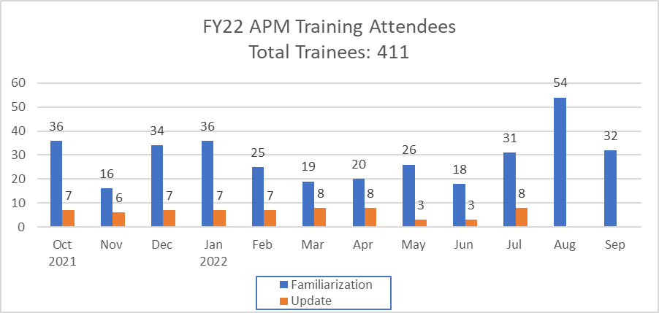

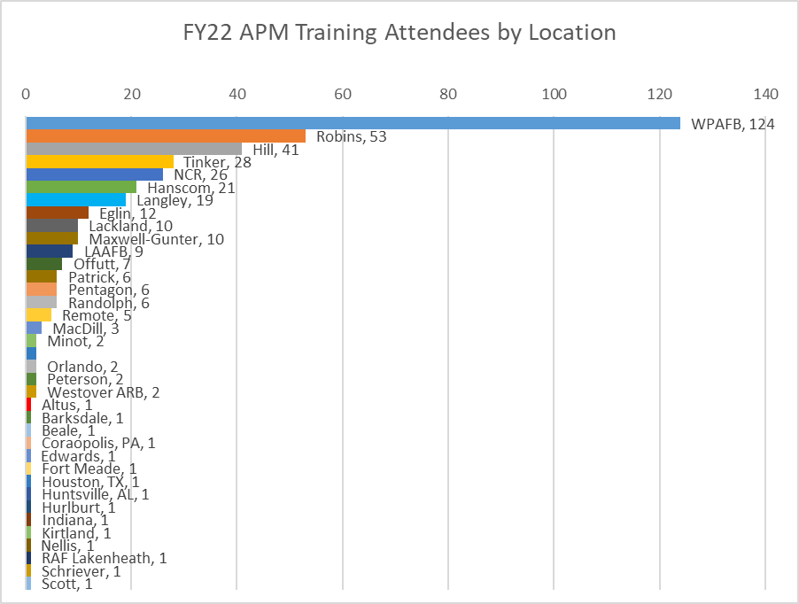

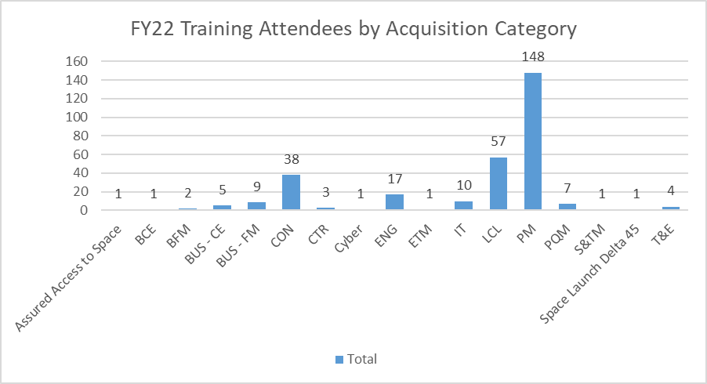

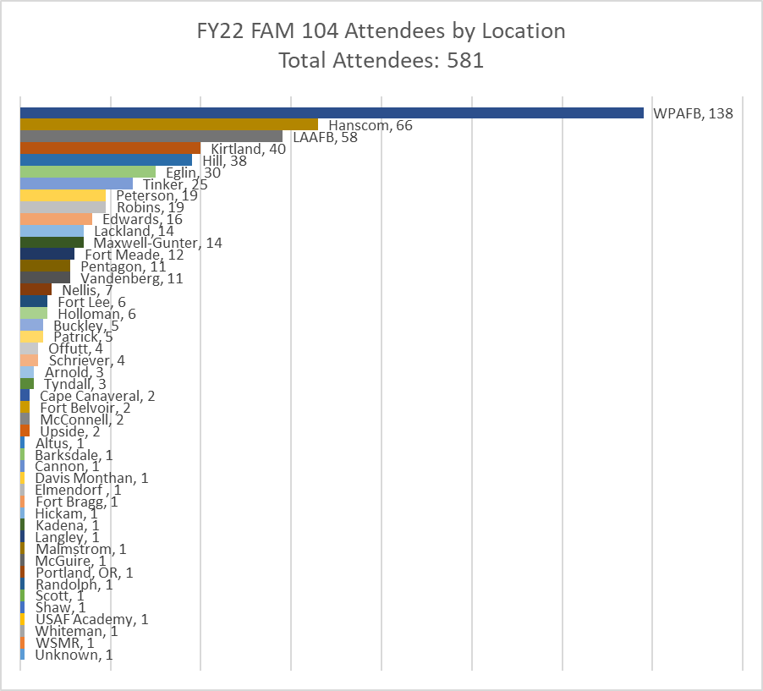

## APM Working Group (APMWG)

Consistent with the direction from the Vice Chief of Staff of the Air Force and the Under Secretary of the Air Force’s 4 Feb 16 Strategic Guidance memorandum, the implementation of the Air Force Strategic Master Plan included the direction to advance the institutionalization of the APM. On 11 Sep 16, SAF/AQ issued a memorandum encouraging the acquisition workforce to leverage the APM as both a reference tool reflecting the processes included in policy/guidance and a baseline for conducting CPI events. In the memorandum, SAF/AQ directed the establishment of the APMWG – a team composed of Air Staff, PEO Staff, and Program Managers. The objective of the APMWG is to recommend content and functionality improvements to the APM as well as identify specific CPI initiatives related to processes contained in the APM.

Highlights of APMWG related activities within FY22 include the following:

1. SAF/SQX joined as a member of the APMWG to begin the definition and integration of Space Force Acquisition processes within the APM.
2. PEO/CM provided a positive response to support the integration of processes underlying the Services pathway within the Adaptive Acquisition Framework.
3. The CPI2 team began discussions with SAF/AQXE personnel to integrate information among the APM and the various ACE SharePoint sites.

|  |  |  |  |  |
| --- | --- | --- | --- | --- |
|  |  |  |  |  |
|  |  |  |  |  |

## APM Update Summaries

The APM changes frequently throughout the year. Below is the summary of major changes to the model. More information can be found in Appendix A.

Version 11.12 Release 4 Nov 2021

Changes due to the following documents: AFLCMC Standard Process for Self-Assessment / Independent Logistics Assessment (ILA), AFLCMC Standard Process for Annual Program Office Cost Estimate, AFLCMC Standard Process for Packaging, Handling, Storage & Transportation (PHS&T) Data, DAFI 23-101, AFLCMC Standard Process for Transition Support Plan (TSP), DAFMAN 63-119

Version 11.13 Release 7 Jan 2022

Changes due to the following document revisions: Air Staff Acquisition Document Coordination Matrix, Executive Order 13526, DoDI 5000.91, DoD Enterprise DevSecOps Fundamentals, DoD Enterprise DevSecOps Strategy Guide, DevSecOps Fundamentals Guidebook: DevSecOps Tools & Activities, DevSecOps Fundamentals Playbook, DoD Enterprise DevSecOps Reference Design: CNCF Kubernetes, DAFGM 2020-63-149-01, AFLCMC Standard Process for Annual Program Office Cost Estimate, AFLCMC Standard Process for Cybersecurity Assessment and Authorization, AFLCMC Standard Process to Develop & Manage AFLCMC Standard Processes & Internal Process Guides, AFLCMC Standard Process for Implementing a Modular Open Systems Approach, AFI 63-101/20-101, DoDI 5000.89_DAFI 99-103, Title 32 Part 117, Incorporating Test and Evaluation into DoD Acquisition Contracts, AFMAN 63-143, HAF MD 1-30, AFLCMC Standard Process for Product Support Business Case Analysis (BCA) Process, DBS Investment Management Guidance, AFLCMC Standard Process to Conduct Unit Self-Assessment Program (USAP)

Version 11.14 Release 11 Feb 2022

Changes due to the following document revisions: JCIDS Manual and CJCSI 5123.01I

Version 11.15 Release 30 Mar 2022

Changes due to the following document revisions: AFMAN 16-1405, MP 5301.9001(i), MP 5301.9001(f), AFLCMC Standard Process for Logistics Health Assessment (LHA), AFLCMC Standard Process for Pre-Award Acquisition Strategy (AS) and Request for Proposal (RFP) Development, AFLCMC Standard Process to Execute Risk and Issue Management in Acquisition Programs, DAFGM 2021-63-01, AFLCMC Standard Process for Intelligence Supportability Analysis, AFLCMC Standard Process for Supply Chain Risk Management, AFLCMC Standard Process for Life Cycle Sustainment Plan

Version 11.16 Release 23 May 2022

Changes due to the following document revisions: DAFI 99-106, DoDI 5000.87_DAFI 63-150, DoDI 5000.95, DoDI 4120.24, Memo: Continuous Authorization to Operate, Title 10 Conversions, DoDI 5000.94, DoDI 5000.02T, DoDI 5000.66, DoDI 5000.83_DAFI 63-113

Version 12.0 Release 27 Jun 2022

Changes due to the following document revisions: AF/A5/7 Capability Development Guidebook Volume 2A, DAFI 90-160, DAFMAN 23-119, DoDI 5000.02, DAFPAM 63-123, Product Support Manager Guidebook

Version 12.1 Release 8 Aug 2022

Changes due to the following document revisions: DAFI 65-601 Volume 1, DoD Systems Engineering Guidebook, DoD Engineering of Defense Systems Guidebook, DoDI 7650.02, AFI 10-503, DoDD 5000.01

Version 12.2 Release 16 Sep 2022

Changes due to the following document revisions: A Guide to Program Management Business Processes, Analysis of Alternatives Cost Estimating Handbook, DoD Product Support Manager Guidebook, DOT&E Test and Evaluation Enterprise Guidebook, Requirements for the Acquisition of Digital Capabilities Guidebook, Defense Acquisition University Course WSM 011, AF/A5/7 Capability Development Guidebook Volume 2C, DoDI 5000.85_DAFI 63-151, DoDI 8510.01, AFI 17-101-DAFGM 2022-01, NIST Special Publication 800-37 Rev2.

## APM NOTAMS Published

The CPI2 branch published 12 NOTAMS to the APM site covering a variety of topics. These topics included on-site training, new documents, and new model enhancements.

|  |  |  |  |
| --- | --- | --- | --- |
| NOTAM Title | Published In | Topic | Date Published |
| [APM 11.13 Update](https://www.afacpo.com/apm/2022/01/07/apm-11-13-update/) | APM News Feed | APM | 7 Jan 22 |
| [Upcoming APM Maintenance](https://www.afacpo.com/apm/2022/01/12/upcoming-apm-maintenance/) | APM News Feed | APM | 12 Jan 22 |
| [Acquisition Process Model Working Group](https://www.afacpo.com/apm/2022/01/13/acquisition-process-model-working-group/) | APM News Feed | APM | 13 Jan 22 |
| [APM Update 11.14](https://www.afacpo.com/apm/2022/02/11/apm-update-11-14/) | APM News Feed | APM | 11 Feb 22 |
| [APM Update Training](https://www.afacpo.com/apm/2022/02/22/apm-update-training/) | APM News Feed | APM | 22 Feb 22 |
| [APM Version 11.15](https://www.afacpo.com/apm/2022/04/12/apm-version-11-15/) | APM News Feed | APM | 12 Apr 22 |
| [APM Version 11.16](https://www.afacpo.com/apm/2022/05/25/apm-version-11-16/) | APM News Feed | APM | 25 May 22 |
| [APM Version 12.0](https://www.afacpo.com/apm/2022/06/27/apm-version-12-0/) | APM News Feed | APM | 27 Jun 22 |
| [Acquisition Process Model ver. 12.1 Released](https://www.afacpo.com/apm/2022/08/08/acquisition-process-model-ver-12-1-released/) | APM News Feed | APM | 8 Aug 22 |
| [Defense Acquisition Guidebook is Being Retired](https://www.afacpo.com/apm/2022/08/15/defense-acquisition-guidebook-is-being-retired/) | APM News Feed | APM | 15 Aug 22 |
| [New APM Landing Page](https://www.afacpo.com/apm/2022/08/23/new-apm-landing-page/) | APM News Feed | APM | 23 Aug 22 |
| [Acquisition Process Model ver. 12.2](https://www.afacpo.com/apm/2022/09/16/acquisition-process-model-ver-12-2/) | APM News Feed | APM | 16 Sep 22 |

## APM Landing Page

Consistent with the implementation of an agile mindset, the CPI2 team instituted an approach to continuous refine the landing page. On 23 August, the CPI2 team redesigned the APM landing page to provide a more user-friendly experience including features such as article tags to facilitate searching and a menu that is always available.

# Value Engineering

## 2023 AF Value Engineering (VE) Plan

Pending direction from OSD, SAF/AQXP will prepare a 2023 VE plan based on timing put forth by the OSD Senior VE Management Official if and when requested.

## Value Engineering Management Advisory Group (VMAG) Participation

The CPI2 branch represents the Air Force on the VMAG.  The VMAG, as outlined in DoDI 4245.14, is composed of the DoD Components’ Senior VE Management Officials and is chaired by the USD (R&E) senior VE Management Official.  The group meets periodically to address the following:  review VE program progress and problems, recommend policy changes as required, exchange concepts and techniques, review honorary award nominations and forward its recommendations to the USD (R&E), recommend and enhance training, and promote VE.

In 2019, OSD decided to discontinue the VE nominations and awards to repurpose the VMAG to develop plans to better encourage programs to utilize VE so OSD can attain better VE participation and savings across the Services.

In anticipation of VMAG reinvigoration, the CPI2 branch is preparing VE reports for the missing years.

# Policy/Guidance Analysis

## Document Review

As part of its analytical support, the CPI2 branch provided Subject Matter Expert review of 132 DoD, AFI, policy and strategy documents with 232 Critical/Substantive comments and 263 Admin comments.  These reviews corrected deficiencies, identified inaccuracies, and recommended content aimed at clarifying guidance.  The additional oversight strengthened the documents and generated discussions that further enhanced the final document(s).

Significant comments are as follow:

1. (DoDI 5000.85 DAFI 63-151) We recommended alignment of this instruction with AFI 63-101/20-101 and current milestone documentation requirements for programs using the Major Capability Acquisition pathway.
2. (HAF MD-10) In addition to incorporating additional DoDIs for completeness, we recommended the inclusion CPO, MPO, and APMWG roles within the Mission Directive.
3. (AFI 63-101/20-101) In addition to incorporating additional DoDIs for completeness, we recommended a variety of organizational and statute-related changes, e.g., Acquisition Data and Analytics superseded Performance Assessment and Root Cause Analysis as a division with OSD(A&S) and Configuration Steering Boards are no longer required in all circumstances.
4. (Capability Development Guidebook 2A) We provided comments to ensure alignment of the requirements processes with all acquisition pathways consistent with current acquisition policy and guidance.
5. (Architecture Executive Committee) We pointed out the lack of authority for the Chief Architect Office, as the SAF/AQ memo from 2 Dec 2020 had expired. This requires a change to HAF MD 1-10 (or similar document) to authorize this committee.
6. (AFPD 13-5 and AFI 13-500) We recommended revisions to the policy directive and the instruction to reflect current organizational realities, such as the impact of the standup of Space Force and the elimination of the Warfighting Integration Center.
7. (AFPD 60-1 and AFI 60-106) We recommended the inclusion of Space Force’s role as well as revisions to multiple policy references.

The CPI2 branch reviewed the following 132 documents in FY22: *Acquisition Workforce Functional Leads;* AFI 35-110, *US Air Force Bands;* AFI 63-101/20-101, *Acquisition/ Logistics, Integrated Life Cycle Management;* AFI 99-120, *Forecasting and Programming Munitions Telemetry and Flight Termination Systems;* AFMAN 17-1203, *Information Technology Asset Management and Accountability;* AFMAN 17-1302, *Cybersecurity Program Management;* AFMAN 21-206, *Aircraft Armament Systems Management;* AFMAN 35-106, *Music, Ceremonies, and Accessions;* AFMAN 35-110, *Air Force Bands;* AFMAN 63-103, *Nuclear Weapon Life-Cycle Activities;* AFMAN 99-120, *Forecasting and Programming Munitions Telemetry and Flight Termination Systems; AQ TMT Business Rules; AQX History Report;* CD Guidebook Volume 2A, *Capability Development Overview and Operational Capability Requirements Governance;* CD Guidebook Volume 2J, *Software Requirements; Cyber Mission Analysis TASKORD Charter; DAF Business Mission Area Governance Charter; DAF Climate Action Plan; DAF Climate Action Plan Appendix;* DAFPD 10-8, *Defense Support of Civil Authorities;* DAFPD 16-1, *Security Cooperation;* DAFI 10-208, *Continuity of Operations Program;* DAFI 10-2601, *Countering WMD Enterprise;* DAFI 117-221, *Government Purchase Card;* DAFI 16-210, *Cyberspace;* DAFI 16-1005, *Modeling and Simulation Management;* DAFI 17-130 DAFGM2021-01, *Cybersecurity Program Management;* DAFI 17-221, *Spectrum Interference Resolution Program;* DAFI 21-103, *Equipment Inventory, Status, and Utilization Reporting;* DAFI 32-9005, *Real Property Accountability;* DAFI 40-402, *Protection of Human Subjects and Adherence to Ethical Standards in DAF-Conducted and -Supported Research;* DAFI 48-145, *Occupational and Environmental Health;* DAFI 48-151, *Thermal Stress Program;* DAFI 63-151, *Major Capability Acquisition;* DAFI 99-106, *Joint Testing;* DAFMAN 21-201, *Munitions Management;* DAFPD 10-8, *Defense Support of Civil Authorities; Data Migration Guidance DAF Ent Data Services; Defense Business Council Memorandum; Defense Intelligence Enterprise Management Arrangement Memorandum; Directive Memorandum for Senior Pentagon Leadership, Strategic Cybersecurity;* DoDD 3000.LR, *Vendor Threat Mitigation;* DoDD 5000.71, *Rapid Fulfillment of Combatant Commander Urgent Operational Needs;* DoDD 5030.55 AFMAN 63-103, *DoD Procedures for Joint DoD-DOE/NNSA, Nuclear Life-cycle Activities;* DoDD 5101.22E, *DoD Executive Agent for DoD Mission Partner Environment;* DoDI 3002.01, *Personnel Recovery in the Department of Defense;* DoDI 3110.05, *Sustainment Health Metrics in Support of Materiel Availability;* DoDI 3216.02 DAFI 40-402, *Protection of Human Subjects;* DoDI 4151.FG, *Military Department Inter-Service Depot Maintenance;* DoDI 4275.05, *Acquisition and Management of Industrial Resources;* DoDI 5000.75 DAFI 63-144, *Business Systems Requirements and Acquisition;* DoDI 5000.85 DAFI 63-151, *Major Capability Acquisition;* DoDI 5200.44, *Protection of Mission Critical Functions to Achieve Trusted Systems and Networks;* DoDI 5205.EG, *Mitigating Risk Related Foreign Ownership;* DoDM 4140.01, *DoD Supply Chain Materiel Management Procedures: Supply Chain Reporting and Metrics;* DoDM 4245.15, *Diminishing Manufacturing and Material Shortages;* DoDM 5200.01 v1 AFMAN 16-1404V3, *Information Security Program; Early Manufacturing and Quality Engineering Guide; Energy Supportability and Demand Reduction in Capability Development; Exception to Policy for Air Force Reserve Contracting Officers; Growth Offset Policy Implementing Instruction;* HAF MD 1-10, *Acquisition, Assistant Secretary of the AF, Acquisition, Technology and Logistics;* HAF MD 1-17, *Space Acquisition;* HAF MD 1-26, *Chief Technology Information Officer;* HAF MD 1-50, *DAF Chief Scientist; Joint Base Operations Guidance;* MD-1050, *The Department of the Air Force Chief Scientist; NAF Procurement Implementation; NDAA FY22 Section 1505 Interim Report; Next Generation IUID – Serialized Item Management; Nuclear Human Capital Governance Charter; Operation Concept Warfare 1.0;* Program Action Directive 21-06, *Evolving Expeditionary Communications Program; Process Improvement Officer CONOPS & Revised Defense Business Council Charter; Secretariat Contact List; Product Support Managers Guidebook;* DoD DEW Policy*; DAF Architecture Executive Review Board Charter;* DAFI 21-150 *Aircraft Repair and Maintenance Cross-Servicing; ASD(A) Memorandum for Centralized Unique Program Identification;* FY22 Statement of Assurance; AFI 13-500 *Nuclear Mission Responsibilities;* DoDI 3216.02_DAFI 40-402 *Protection of Human Subjects;* DoDI 8580.01 *Cybersecurity Strategy in the DAS;* Strategic Readiness Policy*;* AFPD 13-5 *Air Force Nuclear Mission;* AFMAN 21-206 *Aircraft Armament Systems Management;* DAFI 90-302 *The Air Force Inspection System;* HOI 33-14 *Secretariat & Air Staff Responsibilities;* DoDD 3000.09 *Autonomy in Weapon Systems;* SCP memo*;* PAD 21-06 *Evolve Expeditionary Communications for Strategic Competition;* DAFPD 16-1 *Security Cooperation;* PAD 22-02 *Aviation Support Equipment Fleet Management;* PGL 21-05 *Alignment of DAF CIO and CDO; Digital Building Code;* DoDM 4140.01 Vol 12*, "DoD Supply Chain Materiel Management Procedures: Enterprise Logistics Decisions";* AFI 65-302, *External Audit Services;* DAFPD 16-6*, International Arms Control and Non-proliferation Treaties and Agreements and the DoD Foreign Clearance Program Coordination;* HAF MD 1-10*, Assistant Secretary of the Air Force (Acquisition, Technology, and Logistics); Authority to Sign Letters of Support for National Interest Waivers; Delegation of sUAS authorities to the Dean of the USAFA;* DAFI 51-1201*, Negotiation and Dispute Resolution Program; 2022 DoD Sustainability Plan;* DoDI5000.93_DAFI63-149*, Use of Additive Manufacturing; Defense Business Systems Oversight Memorandum; Draft Logistics Functional Community Charter; Capability Development Guidance Memorandum (CDGM)—Joint Simulation Environment (JSE) Integration for Combat-Coded Aircraft;* AFMAN 21-204*, Nuclear Weapons Maintenance;* DAFPD 21-1, *Maintenance of Military Materiel;* DoDI 5200.39*, (High Value) Critical and Enabling Technology Protection;* DAFPD90-16*, Studies and Analysis;* DAFI 63-101/20-101*, Integrated Life Cycle Management;* AFMAN 17-1303*, Cybersecurity Workforce Improvement Program;* AFPD 60-1, *Materiel Standardization and* AFI-60-106 *International Military Standardization Program; DAF Senior Leader Climate (SLC) Forum Charter;* HAFMD1-58*, Office of the Director, DAF Studies and Analysis;* HAFMD 1-57*, Deputy Chief of Staff, Air Force Futures;* DAFPD 90-1*, Policy, Publications, and DoD Issuance Management;* AFMAN 21-203*, Nuclear Accountability Procedures Interim Change 1;* DoDI 5000.90, *Cybersecurity for Acquisition Decision Authorities and Program Managers;* AFMD 63*, Air Force Global Strike Command; and* DoDI 5200.FH*, Acquisition Security.*

# Other Support/Improvement Efforts:

## [SAF/AQX SharePoint Management](https://cs.eis.af.mil/sites/10263)

The CPI2 branch served as administrator and technical support for SAF/AQX with duties such as granting access rights to various users, creating sites, and troubleshooting. The team worked with Erika Castedo to create a SharePoint site for the 2022 Acquisition Leadership Seminar. The site not only provided access to information about the content and logistics for the seminar but also served as the registration location for the event.

The team also revitalized the CPI2 branch SharePoint site to use modern SharePoint 365 themes. The site now includes sections for CPI Tools, Contact Information for the Team, and an Events Calendar. The CPI2 branch created a wiki on the SharePoint site to keep future visitors informed on all CPI2 tools utilized during events. The CPI2 branch also created and populated a public folder to share all Scoping/Charter Documents, In-Briefs, and Out-Briefs for all CPI events for the past 5 years. In support of the SAF/AQ Dashboard Working Group, the CPI2 team is currently working with Maj Sarina Goings (SAF/AQXE) to implement a directorate level timeline calendar for tracking important events across the SAF/AQX divisions.

## Agile Transformation

During FY22, at the request of Mr. Brad Ferguson and under the guidance of an experienced Agile coach Mr. Scott Sinclair, the CPI2 team focused on implementing a lean-agile approach to working and thinking by promoting collaboration, communication, and transparency. To address these areas, the CPI2 team implemented and used several tools and techniques. First, the team created and maintained a roadmap to identify planned and forecasted work. Revised monthly, this roadmap provides a 90-day forecast of expected work with primary emphasis on the next month. Second, using Microsoft Planner as a tool, the CPI2 team translated the roadmap expectations and other customer needs into both current tasks (Kanban board) and future tasks (backlog). The CPI2 team further categorized the tasks into one of three work streams: CPI, APM, Strategic. As the tasks are fleshed out, they are entered in the backlog into the appropriate work streams. When a task is ready to work, it is moved into the Kanban board. To promote collaboration and transparency, the CPI2 team adopted several meetings to help discussions. The CPI2 team conducted biweekly roadmap discussions with Mr. Ferguson to identify any changes to current and upcoming tasks and to continue the buildout of the roadmap. The CPI2 team also held twice weekly stand-ups to talk about current task status, issues or impediments to success, and any needed changes. In addition to the stand-ups, the CPI2 team held refinement meetings weekly to review tasks in the backlog to gain understanding and communication of the work providing all team members a working knowledge of what is coming up. At the end of each month, the CPI2 team conducted a retrospective to discuss what worked well, what didn’t work well, and suggested adjustments. The CPI2 team is continuing to refine the processes and tweak for optimum use while adhering to principles and practices. The CPI2 team will continue to strive for continuous learning and improvements as we move forward with the transformation.

# Appendix A. APM Update Logs

The below control logs provide the details of all the changes to the APM.

|  |  |  |  |  |
| --- | --- | --- | --- | --- |
|  |  |  |  |  |
|  |  |  |  |  |