Air Force Life Cycle Management Center
Standard Process
For
Contract Data Management

Process Owner: AFLCMC/EZSC
Date: 17 Nov 2022
Version: 1.1
Record of Changes. This page summarizes the changes from each revision to the next. Process numbering starts with “1.0”. Minor changes are annotated by changing the second digit, i.e., the first minor change after the basic document would be recorded as “1.1”. Major changes are annotated by changing the first digit, i.e., the first major change after release of the basic document would be numbered as “2.0”.

Record of Changes
Version | Effective Date | Summary
1.0 | 18 Nov 21 | Basic document; Approved at 18 Nov 21 Standard Processes and Products (SP&P) Group
1.1 | 17 Nov 22 | Approved at 17 Nov 22 SP&P Group meeting.  Added:  - Table of Contents  - Acquisition and Sustainment Data Package (ASDP)  - Air Force Product Life Cycle Management (AF-PLM) Teamcenter Data Management Module  - Data Call Email Template  - Contract Data Requirements List (CDRL) Deliverable Preliminary Inspection Checklist  - Comment Resolution Matrix (CRM) Template  - DFARS Subparts 252.204-7008, 252.204-2019, 252.204-2020, and 252.204-2021  Replaced:  - GEIA-859A with SAE GEIA-859B  - Defense Acquisition Guidebook (DAG) (retired) with the new Acquisition Guidebooks  - Department of Defense Instruction (DoDI) 5200.48 with  DoDI 5200.48_DAFI 16-1403  - Department of Defense (DoD) 5220.22M with the 32 Code of Federal Regulation Part 117

Table of Contents
1.0 DESCRIPTION 1
2.0 PURPOSE 1
3.0 ENTRY/EXIT CRITERIA 2
4.0 PROCESS WORKFLOW AND ACTIVITIES 3
5.0 MEASUREMENT 20
6.0 ROLES AND RESPONSIBILITIES 20
7.0 TOOLS 25
8.0 DELIVERY APPROACH 26
9.0 DEFINITIONS, GUIDING PRINCIPLES, GROUND RULES, ASSUMPTIONS AND/OR ACRONYMS 27
10.0 REFERENCES TO LAW, POLICY, INSTRUCTIONS OR GUIDANCE 30
11.0 LIST OF CORRESPONDING AFLCMC SP/IPGs 32
12.0 ATTACHMENTS 33

List of Figures
Figure 1. Data Planning Flowchart 6
Figure 2. Establishment of Data Requirements Flowchart 7
Figure 3. Management of Submitted Data Flowchart 8
Figure 4. Periodic Reviews of CDRLs Flowchart 9

List of Tables
Table 1. SIPOC – Data Planning 3
Table 2. SIPOC – Establishment of Data Requirements 4
Table 3. SIPOC – Management of Submitted Data 5
Table 4. SIPOC – Periodic CDRL Reviews 5
Table 5. Data Planning WBS 9
Table 6. Establishment of Data Requirements WBS 11
Table 7. Management of Submitted Data WBS 19
Table 8. Periodic CDRL Reviews WBS 20

Contract Data Management
- DESCRIPTION
  - Data Management is the process of applying policies, procedures, and tools for the identification and control of data requirements, for assuring the adequacy of data and for facilitating the timely, economical acquisition and availability of data, including digital delivery or access. Contract data includes both technical and non-technical data delivered or produced within, or as a result of, a contractual agreement between the government and a contractor. This is the data required to carry out the program’s acquisition and sustainment strategies, to include program execution.
  - There are many types of data (i.e., data products), for example: reports, charts, plans, procedures, lists, drawings, manuals, technical orders, agendas, presentation charts, meeting minutes, films, photographs, specifications, software, software documentation, diagrams, design sheets, digital artifacts, schedules, provisioning packages, training aids and other program documentation.
  - The term “Data Manager (DM)” is used extensively throughout this document. It is important to note that this refers to any person, regardless of functional area, who has been assigned, and is qualified to perform, the duties of data management. When possible, the DM is part of the Configuration and Data Management functional area.
  - For purposes of clarity, this Contract Data Management process will be broken into four separate sub-processes:
    - Data planning
    - Establishment of data requirements
    - Management of submitted data
    - Periodic Contract Data Requirements List (CDRL) reviews

- PURPOSE
  - The purpose of this process is to ensure that the minimum essential data, based on firm and justified functional requirements, is consistently and effectively acquired and managed throughout the life cycle. Minimum essential data is required to support decisions and program strategies throughout the life cycle. Data requirements shall address access to and delivery of data to ensure the data is in the native digital format and has sufficient content to meet the Acquisition Strategy (AS), Intellectual Property (IP) Strategy, Sustainment Strategy, System Engineering Technical Reviews (SETRs), and acquisition milestone decisions. Data needs should address digital acquisition and digital engineering requirements and be continuously reviewed during the life of the program.

- ENTRY/EXIT CRITERIA
  - Data Planning Entry Criteria
    - Draft AS documentation (for example, Acquisition, Intellectual Property (IP), and Sustainment Strategies, etc.)
  - Data Planning Exit Criteria
    - Approved AS, including IP Strategy, Sustainment Strategies, etc. (Note that the Data Management Strategy must be approved and integrated into the AS.)
    - Defined data management processes
  - Establishment of Data Requirements Entry Criteria
    - Documented program with an approved AS
    - Established Integrated Product Team (IPT)
    - Draft Statement of Objectives (SOO)/Performance Work Statement (PWS)/‌Statement of Work (SOW) as applicable
  - Establishment of Data Requirements Exit Criteria
    - Approved data requirements
    - Finalized draft Statement of Objectives (SOO)/Performance Work Statement (PWS)/Statement of Work (SOW) as applicable
    - Data Requirements Review Board (DRRB) minutes
    - DRRB CDRL Table or equivalent
    - Finalized CDRLs and associated attachments, including CDRL Supplemental Section (General Instructions/Notes), on contract
  - Management of Submitted Data Entry Criteria
    - CDRLs on contract
    - Program data schedule
    - Delivered Data Submittal(s)
  - Management of Submitted Data Exit Criteria
    - Processed Data Submittals
  - Periodic CDRL Reviews Entry Criteria
    - Current CDRLs on contract
  - Periodic CDRL Reviews Exit Criteria
    - Revised CDRLs as applicable

- PROCESS WORKFLOW AND ACTIVITIES
  - Suppliers, Inputs, Process, Outputs, Customers (SIPOC) Table
    - Description
SIPOC Tables identify Suppliers, the Inputs they provide to a process step/activity, the Process Step/Activity that receives those inputs, the Outputs of those activities, and the Customers of those outputs. As such, they provide a summary of major process activities that will be necessary to produce the desired products and permit exiting the process. The process activities can be read in order down the center column of the table. They assume success at each step and are an easy-to-understand picture of the process in tabular form. The party responsible for performing the process step in one row becomes the supplier in the next, the outputs of their process steps become the input on the next row, and the customer at the end of one row becomes the party responsible for performing the process activities shown in the next row.

Table 1. SIPOC – Data Planning
Suppliers | Inputs | Process | Outputs | Customers
Program Manager (PM), DM, Gov Program Office, Logistics, Technical Order Management Agency (TOMA) | Availability of data management tools  Requirement for contractor-prepared data  Draft AS documentation | Plan for receipt of data, including choice of data repository and data management tool, development of a Data Management Strategy and data management process | Decision on data repository and management tool  Data Management Strategy and process | PM  DM  Gov IPT

Table 2. SIPOC – Establishment of Data Requirements
Suppliers | Inputs | Process | Outputs | Customers
Data Requestors, Program Management, Engineering, Manufacturing, Logistics, Contracting, Finance, Configuration/Data Management, Using Command, Cybersecurity, Other users of the data | Draft SOO, SOW or PWS  Program description  Milestone events  Data Call suspenses  AS documentation  Follow-on acquisition strategy Life-Cycle Management Plan (LCMP)  Draft attachments to CDRLs (e.g., Technical Manual Contract Requirements (TMCR)) | Data Call | Requested data requirements with justification | DM  PM
DM, PM | Identified data requirements with justification | Initial CDRL Package Development | Draft CDRL Package | IPT  PM  DM
DM, IPT, PM | Draft CDRL Package  Data requirement justifications  DRRB CDRL Table completed to Column H  (or equivalent) | DRRB | Approved data requirements  DRRB CDRL Table completed to Column J  (or equivalent) | DM
DM | Approved data requirements  DRRB CDRL Table | CDRL Package Finalization | Final CDRL Package | Procuring Contracting Officer (PCO)  IPT  PM
PCO, PM, IPT | Final CDRL Package and all necessary Request for Proposal (RFP) documentation | RFP Preparation and Release | Final RFP | Offeror(s)
Offeror(s) | Proposal | Proposal Evaluation | Contract Award | PCO  Contractor  Gov reviewers  IPT
Government DM, Contractor | Contractual data requirements and schedule | Post Award Conference | Agreement on data deliverables and schedule | IPT  Contractor  DM

Table 3. SIPOC – Management of Submitted Data
Suppliers | Inputs | Process | Outputs | Customers
Contractor | Data products submitted in accordance with CDRLs | Data Submittal | Data deliverables received in data tool | DM
DM | Data deliverables logged in | DM initial inspection of data deliverables | Initial determination that data meets requirements of CDRL and DID | CDRL Office of Primary Responsibility (OPR)  CDRL reviewers
CDRL OPR and reviewers | Determination as to acceptability of data deliverable | Inspection and Acceptance of submitted data | Data delivery acceptance based on quality of content | Gov PCO

Table 4. SIPOC – Periodic CDRL Reviews
Suppliers | Inputs | Process | Outputs | Customers
PM, DM, IPT | CDRLs on contract | Periodic Reviews of CDRLs | Revised CDRLs as indicated | Gov  Contractor

  - Process Flowchart

Figure 1. Data Planning Flowchart
Link to WBS
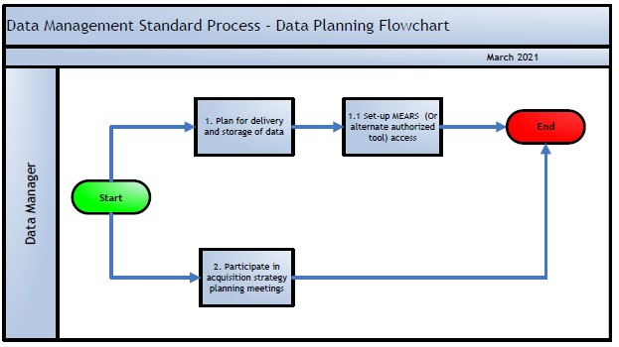

Figure 2. Establishment of Data Requirements Flowchart
Link to WBS

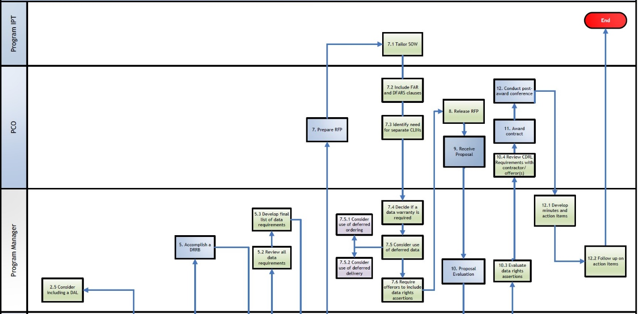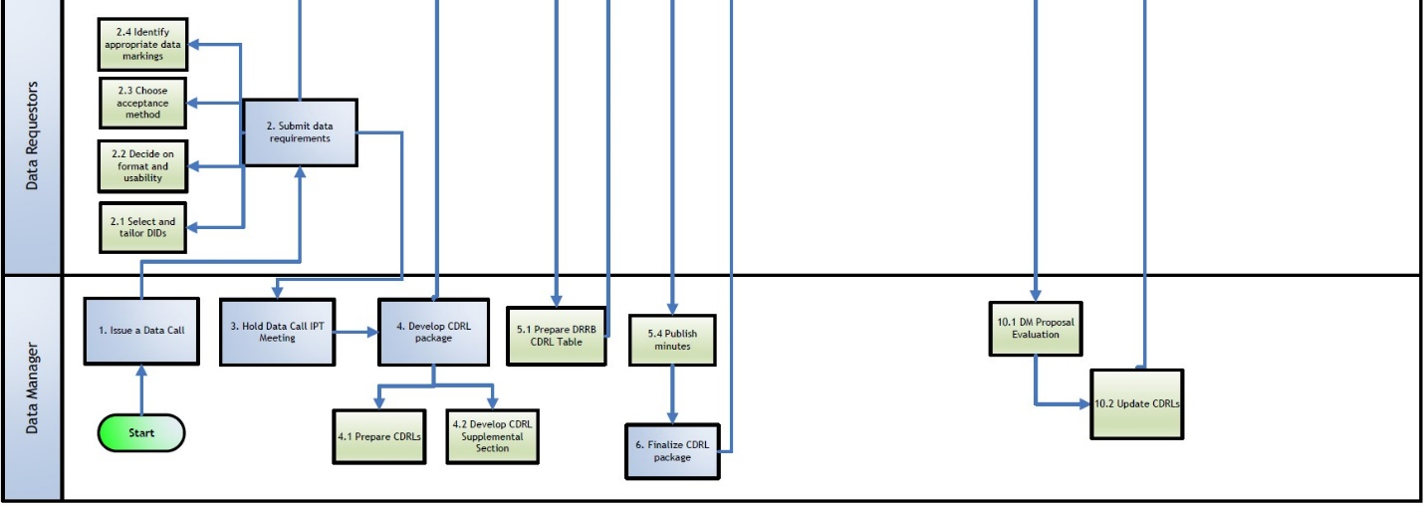

Figure 3. Management of Submitted Data Flowchart
Link to WBS

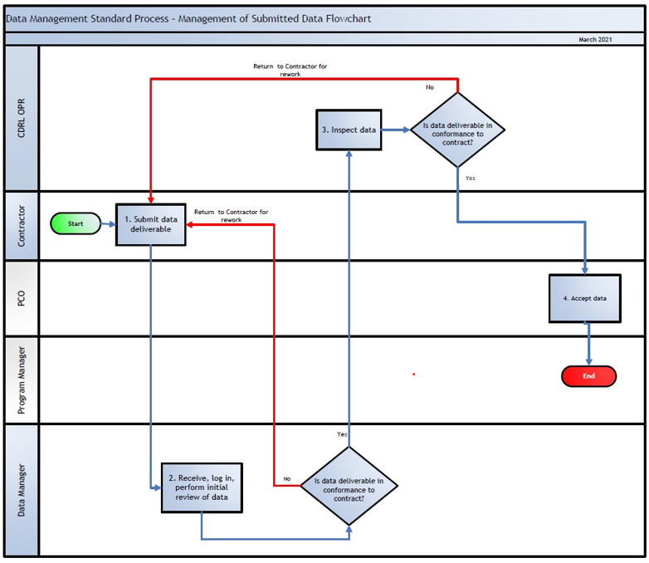

Figure 4. Periodic Reviews of CDRLs Flowchart
(link to WBS)
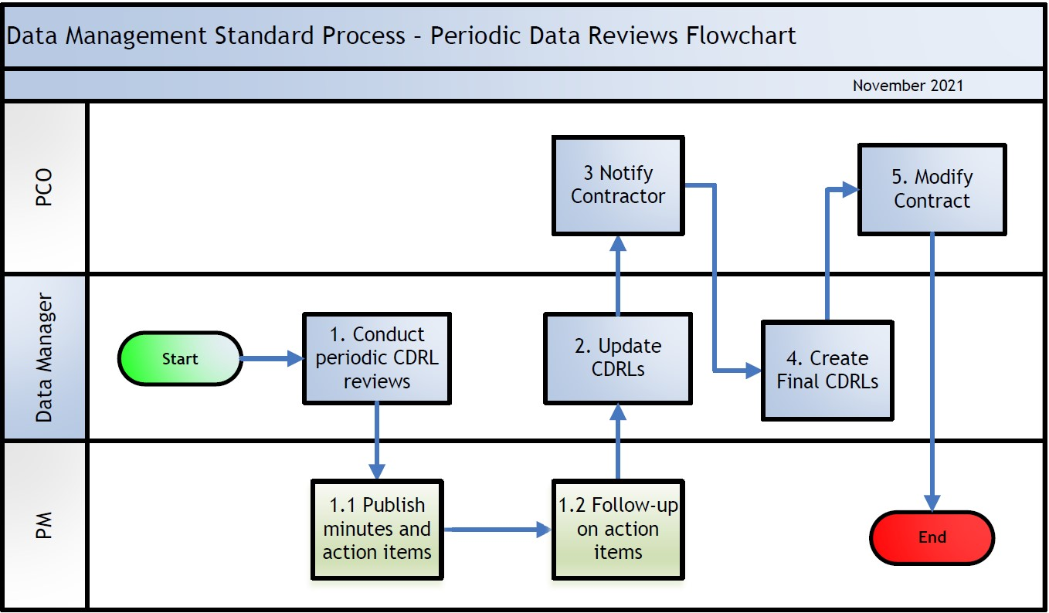

  - Work Breakdown Structure (WBS)
Table 5. Data Planning WBS
WBS | Activity | Description | OPR
1. | Plan for the delivery and storage of data | Data management system(s) provide access, retention, integration, sharing, transferring, and conversion of data throughout the product’s life cycle. Components of a typical system include data authoring tools, a data repository, and a range of CM and access control functions. The data management system’s repository function stores data and controls access or release of data to authorized users. The government and contractor normally have separate and distinct data management systems. The management and sustainment of data is the overall responsibility of the PM, with support of the IPT, for the program or system(s) regardless of where the data resides. A data management system should support the following government activities: (1) Technology insertion for affordability improvements during re-procurement and post-production support. (2) CM processes. (3) Provision as a ready reference for the systems engineering effort. (4) Data correlation and traceability (among performance requirements, designs, decisions, rationale, and other related program planning and reporting elements). (5) Total life cycle systems management efforts and receipt of the data required for performance-based logistics implementation. (6) Long-term access to data, which facilitates: a) Competitive sourcing decisions. (b) Maintenance and sustainment analysis. (c) Contract service risk assessment over the life of the system. (d) Qualifying additional sources or Item, Component or Processes (ICPs) by “internal only” government review of contractor restricted data, such as the government’s data rights that are Government Purpose Rights (GPR), Small Business Innovation Research (SBIR), Limited Rights (LR), etc. (DFARS 252.227-7013), in the contractor-prepared data. (e) Follow-on procurements. The data management system should support the following functions: (1) Cybersecurity for DoD Controlled Unclassified Information (CUI). (a) Cybersecurity for DoD Systems. DoDI 8510.01 is the backbone of Cybersecurity, and DoDI 8500.01 establishes cybersecurity requirements for DoD systems that contain DoD information. (b) Cybersecurity for Vendor Systems. The appropriate clause for DFARS Subparts 252.204-7008 and 252.204-7012 must be included in contracts that involve DoD CUI, including controlled technical information to safeguard this information located and maintained on the contractor owned and operated information system. DFARS clauses 252.204-7019, 252.204-7020, and 252.204-7021 must be included in contracts to require DoD assessments of the cyber system that processes, transmits, or stores DoD or federal government information. (2) Data Maintenance. (3) Data Loss Prevention. Procedures to protect data on any storage media from loss or inadvertent destruction should be established and applied in accordance with DFARS Clause 252.204-7008 and 252.204-7012. (4) Data Sharing/Exchange. DoDIs 8320.02 and 8320.07 define DoD information sharing policies and procedures. Wherever possible, data delivery methods should use modern information technology services for digital delivery of the contractually required information. The requirements for digital delivery should be consistent with the government’s capabilities to receive, use, store, maintain, and distribute the data and to protect the data from unauthorized release or disclosure. A common digital tool that may be required on the CDRL is use of the Wide Area Work Flow (WAWF) e-Business suite. Ensure that the data management system supports required government activities. Ensure that the preferred CDRL (DD Forms 1423, 1423-1 or 1423-2) is supported by the data management system. Refer to the Air Force Digital Transformation, Acquisition and Sustainment Data Package at https://usaf.dps.mil/teams/afmcde/SitePages/ASDP-Contracts-Guidance.aspx. | DM
1.1 | Set up MEARS (or alternate authorized tool) access | The designated AFLCMC data repository and management tool is MEARS (Multi-User Engineering Change Proposal Automated Review System). Programs must contact AFLCMC/EZSC to coordinate MEARS setup or to provide justification for any alternate system to be used in place of MEARS. MEARS is a web-based application that specializes in Configuration, Change and Data Management. It manages the creation, review, and archival of all information in a centralized data repository that provides easy access to all users via virtual collaboration. MEARS can be used to generate, track and report CDRL activities for a program. The tracking system is a key tool used to verify that the contractor has met data delivery requirements in support of data Contract Line Item Number (CLIN) closeout. Funding for MEARS is currently provided at the Program Executive Officer (PEO) level. AFLCMC directorates which participate in the annual PEO Assessment are eligible to obtain user accounts at no additional charge by contacting their Division’s MEARS Point of Contact (POC) or the program administrators at the EN-EZ C/DM Home Office. All members of an IPT who need to access the data on a particular program must have a user account. DMs at Original Equipment Manufacturer (OEM) contractor facilities can be set up to deliver data into MEARS. The requirement for a contractor to deliver data into MEARS should be communicated early in order to set expectation, including any additional costs that may be incurred. Two or three user accounts, as needed, are provided at no cost. In order to access MEARS, the OEM Contractor must use either a CAC card or a PKI certificate. Information on obtaining a PKI certificate can be found at (Link: DM MEARS). A PKI certificate incurs a small annual fee. If an alternate system is proposed for use, the program must also submit proof that all required cybersecurity measures are in place for that alternate system and any associated software tool, as identified in DoDI 8500.01, and also NIST SP 800-171r2 if the tool operates from and stores data within a Nonfederal System. Air Force Product Life Cycle Management (AF-PLM) is an approved alternative. Programs must contact the AF-PLM Capability Support Office (CSO) to request and coordinate access to the Data Management Module currently available in Teamcenter (Tc). Visit the AF-PLM CSO website for general information regarding AF-PLM at https://usaf.dps.mil/teams/AFPLM/PLM/SitePages/Home.aspx. The DM assists the program office in ensuring that any data repository used for storing digital-model deliverables, or forms of structured data, is an AF approved tool that resides in an AF approved environment, and that these digital tools are accessible within the program office. | DM
2. | Participate in acquisition strategy planning meetings | Participate in AS planning meetings, ensuring that a Data Management Strategy is developed as part of the AS. | DM

Table 6. Establishment of Data Requirements WBS
WBS | Activity | Description | OPR
1. | Issue a Data Call | Follow guidance in DoDM 5010.12-M Section C2.2. See tailorable ‘Data Call Email Template’ (Link: DM Resources). | DM
2. | Submit data requirements | Data Call participants prepare and submit their minimum essential data requirements to be included in a RFP or solicitation, using the CDRL Substantiation Worksheet (Link: DM Resources), or an alternate means that includes all of the information provided by that worksheet. The requestor should justify all data requirements, along with their intended use and minimum level of data rights needed. Follow guidance in DoDM 5010.12-M Section C2.3. | Data Requestors
2.1 | Select and tailor Data Item Descriptions | The data requirements are selected from authorized Data Item Descriptions (DIDs). See ‘Commonly Used DIDs’ (Link: DM Resources). There are two types of DIDs – repetitive and one-time. Authorized repetitive DIDs may be found at the following ASSIST website: https://quicksearch.dla.mil/qssearch.aspx. Per MIL-STD-963C, 4.4.5(c), requirements may be tailored out, but additional requirements shall not be added by tailoring. In this situation, a new or revised repetitive DID or a one-time DID should be prepared. Follow guidance in DoDM 5010.12-M Sections C3.2.1, C3.2.2 and C8.2.4. Air Force one-time DID requests are reviewed and approved by AFMC/ENS, submitted through AFLCMC/EZSS. See ‘DID Approval Process’ (Link: DM Resources). All Acquisition and Sustainment Data Package (ASDP) endorsed DIDs can be found in ASSIST by searching for the term ‘ASDP.’ | Data Requestors
2.2 | Decide on data format and usability | The format specified for delivered data can significantly affect the usability of the data after it is delivered. Programs should determine the data structure and functional capabilities needed to support each data requirement based on how the data will be used, by whom, where it will be stored, and how it will be shared or exchanged. Specifying a neutral format such as Standard for the Exchange of Product Model Data for 3-dimensional computer-aided design files or portable document format for documents or 2-dimensional drawings requires an export or translation process by the contractor. This process usually results in a loss of fidelity and functionality when compared to the native files created by the contractor. Programs should consider procuring native or both native and neutral files to support maximum functionality of the data. Furthermore, where government standards do not apply, programs should use technical and commercial data standards as used in industry in lieu of government standards, except where inconsistent with law or inseparable. For further information, refer to Office Management and Budget (OMB) Circular A-119 and DoDM 5010.12-M Section C3.2.4. | Data Requestors
2.3 | Choose inspection and acceptance method (Block 7 of the DD 1423-1) | Specific use of a DD Form 250 is usually limited to and required for final data products intended to be limited to baselines for further government applications, such as engineering drawings, specifications, and Technical Manuals (TMs). Upon delivery, the PCO or designee must perform the quality assurance steps established in FAR Part 46. The requirement for DD Form 250 use should not be applied to preliminary, draft, or interim copies. Where submittal of draft or interim copies is required, a remark should be inserted in Block 16 that distribution to other addressees in Block 14 should be delayed until acceptance has been affected. Such a note should also provide maximum turnaround time for both government review and contractor accommodation of comments. The codes are:  - SS. The SS code (Source/Source) is used when both the inspection and acceptance functions have been assigned to the on-site government contract administrator (administrative contracting officer, or agency plant representative office) and will be performed at the source.  - DD. The DD code (Destination/Destination) is used when both the inspection and acceptance functions are to be performed at destination. If the inspecting and accepting authority is not the first addressee in Block 14, a qualifying remark should be inserted in Block 16.  - SD. The SD code (Source/Destination) is used when inspection is assigned to the on-site government contract administrator, and acceptance is at destination. The accepting authority should be identified in Block 16 remarks if it is other than the first addressee in Block 14.  - DS. The DS code (Destination/Source) is used when inspection is at destination and acceptance is by the on-site government contract administrator. If the inspecting authority is other than first addressee in Block 14, identify the authority in a Block 16 note. This DS code is rarely used, but could apply when the on-site contract administrator desires a review by others before acceptance.  - LT. The LT code (Letter of Transmittal only) is used when a record of delivery is desired, but formal DD Form 250 inspection and acceptance is not required, and the program office does not need to have a DD Form 250 for each piece of data developed by the contractor. LT is not authorized for use when inspection is required. LT is thus not authorized for data comprising final delivery of Technical Data Packages (TDPs) or for final delivery of TMs. LT may, however, be used in the special case where the contracting agency does not desire to have separate DD Form 250 but does desire to have a government quality assurance (QA) representative perform inspection. The government QA representative will be listed on the distribution in Block 14 and requested, via the QA letter of instruction, to provide comments.  - NO. The NO code (No inspection or acceptance required) applies when the data product includes the transmittal record (e.g., is part of correspondence text), or a record of delivery is otherwise impractical (e.g., electronic media transmission). The authority to reject by anyone other than the PCO must be specified in the contract. The NO code is not to be used for data comprising final delivery of TDPs or final delivery of TMs.  - XX. The XX code (Inspection/acceptance requirements specified elsewhere in the contract) is used when another section of the contract outlines the inspection and acceptance requirements and procedures applicable to the data requirement. | Data Requestors
2.4 | Identify appropriate data markings | All noncommercial item technical data (TD) and noncommercial computer software to be distributed, whether hard copy or digital format, should be marked in accordance with DoDI 5230.24 for distribution statement and export-control warning, and in accordance with DoDM 5200.01 Volumes 1-3 security classification. Markings communicate the level of government data rights to use the data. They also indicate how data are to be handled and controlled to ensure data are made available to promote progress and innovation without compromising any commercial or national security concerns.  Copyright Notice. Sections 401 and 402 of Title 17, U.S.C. define the requirements for a copyright “notice” or marking. The three basic elements of a copyright notice are the symbol ©, word “copyright” or abbreviation “copr." plus the year and owner’s name. Contractors are allowed to place a copyright marking on delivered data as long as it is consistent with the stated license rights.  Distribution Statement. Distribution statements are mandatory for all newly generated, revised, or previously unmarked technical data at the time they are delivered to the government. The DoD activity that sponsored the work generating the data or receiving the data is known as the Controlling DoD Office (CDO). The CDO should assign distribution statements to all data generated in their programs in accordance with DoDI 5230.24 before primary distribution. Although five of the six distribution statements indicate that public disclosure may be inappropriate, DMs and other DoD personnel should be aware that distribution statements are not in themselves authority to withhold unclassified TD and computer software from public disclosure. Such determinations should be made in accordance with DoDD 5400.07.  Export-Control Warning Notice. Information that contains export-controlled TD must be marked with the export control warning in accordance with DoDD 5230.25. Any document so marked must also be assigned Distribution Statement B, C, D, E, or F, as defined in DoDI 5230.24, and specify “Export Controlled” as a reason for the limitation. Distribution statement A, which authorizes public release, cannot be used in conjunction with the export-control warning. Contact the Defense Technology Security Administration office for assistance with export-control regulations.  Security Classification and Other Controls. Classified data and CUI should be marked in accordance with 5200.01v2_AFMAN 16-1404v2, DoDI 5200.48_DAFI 16-1403, and DoDI 5230.24 for controlled technical information. When the contract involves classified information, the government must also provide the contractor with a completed DD Form 254, “Contract Security Classification Specification” in accordance with 32 Code of Federal Regulation Part 117, which will set forth any additional contractor requirements for receipt, handling, and release of classified data. The completed DD Form 254 should be an attachment to the contract.  Data Rights Restrictions. DFARS Subparts 252.227-7013, 252.227-7014, and 252.227-7018 define the restrictive rights marking legends allowed on noncommercial item TD and noncommercial computer software delivered to the U.S. Government. The format and content of the legends defined in these clauses are the only permitted means to identify GPR, RR, LR, SBIR, and SNLR restrictions on delivered noncommercial data. “Proprietary” is not an acceptable marking for noncommercial item TD or noncommercial computer software delivered to the government.  In addition to the restrictive rights marking legend (GPR, RR, LR, SBIR, or SNLR), the actual TD subject to the restriction must be identified in accordance with DFARS Subpart 252.227-7013. The only exception to this requirement is if every piece of data on the page, within the document, or within the file, is subject to the asserted limitation or restriction.  Commercial Markings. There are no requirements for a specified restrictive legend or marking for commercial item TD in accordance with the clause at DFARS Subpart 252.227-7015. The cited DFARS clause does require that the data be marked to indicate that the data is subject to restrictions, or else the U.S. Government is “released from liability” for any use or release of that data. Thus, the data can be marked with “Proprietary” or other language that denotes the data is subject to use, release, or disclosure restrictions. Markings for commercial computer software or its documentation are not explicitly addressed in DFARS Subpart 252.227. DFARS Subpart 227.7202-3 specifies that the government shall have only the rights specified in the license under which the commercial computer software or commercial computer software documentation was obtained. The U.S. Government must negotiate with the contractor if there is a need for rights that are not conveyed under the license customarily provided to the public. Those negotiations will determine marking requirements, which are enumerated in the contract license agreement.  Additional Marking. Markings in addition to the standard prescriptions may be used in accordance with a specific agreement between the government and third parties in accordance with DoDI 5230.24.  Responsibility for Marking. The CDO is responsible for selecting the correct distribution statement, security classification, and export control warning markings, when applicable, pursuant with DoDI 5230.24 and DoDM 5200.01v2_AFMAN 16-1404v2. The CDO should ensure that all marking requirements are annotated on the CDRL. Additionally, Block 16 of the CDRL (or the CDRL Supplemental Section) should contain the exact verbiage of the applicable distribution statement identified in Block 9 for the data product. | Data Requestors
2.5 | Consider the use of a Data Accession List | The inclusion of a Data Accession List (DAL) requirement in the contract may be helpful to determine what additional data can be ordered via the deferred ordering clause (DFAR 252.227-7027). The DAL specifies internally generated data and computer software used by the contractor to develop, test and manage a program. It includes identification of the data rights for each listed item. Additionally, it identifies contractor internal data that has been generated by the contractor in compliance with the work effort described in the SOW. The DAL is a listing of data, not the actual documents. It does not include data that is required by a CDRL and should not be used as a method to reduce the number of CDRLs on contract. The government can request data that is listed on the DAL. The DAL is not normally an approval item; however, the government can challenge the data listed on the DAL. The DAL is an index of the data generated by the contractor as a result of the work effort described in the SOW. The government may order a DAL in accordance with the latest version of DI-MGMT-81453. The DAL is not a requirement for delivery of all the data listed, but the government can use the list to order additional data via the deferred ordering clause. | PM
3. | Hold Data Call IPT Meeting | The DM, working under the direction of the PM, should be involved in setting up the Data Call IPT meetings. These meetings should discuss program requirements, review existing data requirement input, and identify any additional data requirements. These meeting should be attended by representatives of the acquisition functional areas, such as Program Management, Engineering, Configuration/Data Management, Financial Management, Test and Evaluation, Logistics and Contracting, as applicable. The DM and the functional representatives identify, define, or review the applicable data acquisition documents and DIDs for each data requirement. During IPT meetings, all acquisition program requirements and their essential data requirements should be discussed among all functional area representatives. Functional representatives should provide their supporting data, such as program background information, requirements, the AS and SOW/PWS/SOO. The DM should provide the Data Call email and the completed CDRL Substantiation Worksheets or alternative. The functional areas subject matter experts will use this information to identify or develop all of the appropriate documentation defining the data requirements. This documentation should be incorporated into the acquisition requirements. | DM
4. | Develop draft CDRL package | The DM creates the draft CDRL Package, making sure to identify an OPR for each CDRL, by using the information gathered through the Data Call and the subsequent IPT meeting(s). | DM
4.1 | Prepare CDRLs | Follow guidance in DoD 5010.12-M Section C3.3.3. Each data deliverable identified in a CDRL should map to a task in the SOW, PWS or SOO (referenced in Block 5 of the DD Form 1423-1). | DM
4.2 | Develop a CDRL Supplemental Section | CDRL Packages should include a CDRL Supplemental Section (General Instructions/Notes). The CDRL Supplemental Section provides information that applies to the entire CDRL Package to assist the contractor in the preparation of data deliverables, including definition of acronyms/abbreviations/codes, mailing addresses, procedures/additional information regarding review/approval for approval items, copies of any one-time DIDs, procedures for accommodating/accepting data electronically transmitted, criteria/procedures for marking data , and other clarifications/instructions as needed, for example, specific versions of software to be used, when or if PDF files are acceptable vs the native application, i.e., Excel files that can be sorted, manipulated, etc. See ‘CDRL General Instructions Template’ (Link: DM Resources). | DM
5. | Accomplish a DRRB | A Data Requirements Review Board (DRRB) should be convened once the draft CDRL Package has been prepared. DRRBs are held for any acquisition having an estimated total contract cost of five million dollars or more. Lower-dollar thresholds for convening a DRRB may be established by each PM based on the circumstances of the acquisition. The DoD Components define when a DRRB is required. Follow guidance in DoDM 5010.12-M Section C2.6. | PM
5.1 | Prepare the DRRB CDRL Table | The DM fills out Rows A-H of the DRRB CDRL Table in advance of the meeting. Alternately, an equivalent means may be used that ensures data rights are evaluated, agreed upon, and documented for all technical CDRLs in advance of contract award. See DRRB CDRL Table Template (Link: DM Resources). | DM
5.2 | Review all data requirements | Follow guidance in DoDM 5010.12-M Section C2.6. The DRRB chair (usually the PM or designee) approves or disapproves each request based on the justification, program need, and tailoring. Consideration should be made in regard to delivery time frames, so that a functional reviewer can reasonably review the documents within the specified time frames. | PM
5.3 | Develop a final list of all data requirements | The results of the DRRB should include an agreed upon list of defined data requirements. The DRRB CDRL Table, if being used, should be updated to include the additional columns per the instructions within the spreadsheet. | PM
5.4 | Publish minutes | Minutes of the DRRB should be captured to document the approval or reasons for disapproval of requested data items, and to document any action items assigned at the meeting. | DM
6. | Finalize the CDRL package | The DM updates the CDRL Package in accordance with the decisions made at the DRRB. The DM obtains the PM’s approval signature on the CDRL Package. Any changes to the CDRLs after this point must be approved by the PM. | DM
7. | Prepare RFP | The list of CDRLs (or the CDRLs themselves), including the CDRL Supplemental Section, resulting from the DRRB will accompany the RFP (which includes the SOO, SOW or PWS). The PCO integrates the CDRL Package as an exhibit (Section J) in the model contract. Defense Federal Acquisition Regulations Supplement (DFARS) 215.470(b) requires that DD Form 1423, CDRL, is included with the solicitation when data are required to be delivered under a contract (ref DoDM 5010.12-M Section C3.3.1). See ‘RFP Section L and M Examples’ (Link: DM Resources). | PCO
7.1 | Examine the SOW or PWS, to ensure that the tasks for data requirements are essential and relevant to the acquisition | Follow guidance in DoDM 5010.12-M Section C3.2. | Gov IPT
7.2 | Include the appropriate FAR and DFARS clauses | In addition to accounting for data requirements, the PCO should verify that the solicitation includes the appropriate data acquisition related FAR and DFARS provisions and clauses. | PCO
7.3 | Identify the need for separate Contract Line Item Numbers (CLINs) | In accordance with Office of the Under Secretary of Defense (OUSD) Memo “Ensuring Proper Line Item Structure to Support Asset Valuation”, dated 24 Mar 20, “accounting activities must verify all proposed contract line items are properly accounted for and segregated into separate line items between capitalized assets and expenses.” Determine the necessity of separate CLINs for each TM (including TCTOs) and/or TDP. The requiring activity needs to identify separate CLINs for data-related products a contractor is to deliver in the solicitation. This also allows these products to be priced separately from the administrative, development, design, or production tasks. Items that should be considered for separate CLINs include TDPs, TMs, computer software, deferred delivery data, and acquisition of greater than the standard data rights. Some data requirements specified on a separate CLIN may need special inspection and acceptance requirements. Such requirements should be addressed in Section E of the solicitation. Each CLIN must be defined and described in detail in order to prevent confusion when ordering or tracking parts or items in a contract. | PCO
7.4 | Decide if a data warranty is required | Warranties on TD and computer software should be obtained when practicable and cost effective. The remedies contained in DFARS Subpart 252.246-7001 are available to the U.S. Government if warranties are included and should be considered in deciding whether to obtain warranties of data. When deciding whether to use extended liability provisions, consider the likelihood that correction or replacement of the non-conforming data, or a price adjustment, will give adequate protection to the U.S. Government. Also consider whether the warranty clause will be an effective deterrent against the contractor providing non-conforming data. The PM may begin this activity earlier in the process. | PM
7.5 | Consider the use of deferred data | There are two deferred data acquisition techniques the government can use to ensure data is only ordered or delivered when needed. The first technique is deferred ordering. This technique delays the ordering of data generated in the performance of the contract until the government determines what data is actually needed and when it is needed. This technique is normally used during the solicitation and negotiation phases and ensures the availability of raw data while avoiding the cost of buying the data if the need never arises. The second technique is deferred delivery. This technique delays the delivery of data until the government determines when the data should be delivered. This technique is normally used when, during the solicitation and negotiation stages, specific requirements for the data can be determined, but the time or place of delivery is not certain. The cost of the data will be negotiated before contract award. The PM may begin this activity earlier in the process. | PM
7.5.1 | Consider the use of deferred ordering | Follow guidance in DoDM 5010.12-M Section C3.5.1. | PM
7.5.2 | Consider the use of deferred delivery | Follow guidance in DoDM 5010.12-M Section C3.5.2. | PM
7.6 | Require offerors to include data rights assertions | The PCO should ensure that all aspects of the data requirements are integrated when finalizing the RFP or solicitation. While developing a solicitation, cite language from DFARS Subpart 252.227-7017 which requires offerors to insert in an attachment to their proposal an assertion of any TD or computer software to be delivered that is subject to less than unlimited rights (UR). The contract data requirement and the appropriate requirements from DFARS Subparts 227.4 and 227.71 obligate the contractor to comply with three critical contract procedures with regards to data rights: asserting, marking, and justifying. These procedures require the contractor to clarify its position regarding the government’s rights in the data to be provided to the U.S. Government and should highlight any areas of disagreement between parties. A proper assertion should be made in the offeror’s proposal and incorporated into the contract or made before delivery and justified as a “new” or “inadvertent omission” not affecting source selection. The contractor should specifically identify (e.g., version number, date, and location) pieces of data (not documents that might contain such data), the related ICP along with the level of data rights to which the contractor believes the government is entitled, and the supporting rationale. When a proper assertion is not made before contract award (pursuant to DFARS), the contractor must deliver data not associated with an assertion with unlimited rights. The only exceptions are defined in DFARS Subparts 252.227-7013, 252.227-7014, and 252.227-7018. Other assertions may be identified after award when they are based on new information or inadvertent omissions unless the inadvertent omissions would have materially affected the source selection decision. | PCO
8. | Release RFP | The PCO releases solicitation(s) to the contractor (sole source) or to https://sam.gov/content/home (open competition) or other appropriate publicizing method, based on a given competition. | PCO
9. | Receive Proposal | Receive the proposal(s) from the contractor(s). | PCO
10. | Proposal Evaluation | Evaluate the proposal(s). | PM
10.1 | DM Proposal Evaluation | Evaluate the DM portion of the proposal by reading and understanding the SOW or PWS and the offeror's cost and technical proposal, reviewing the scope of the tasks proposed by the contractor, reviewing the contractor's estimating methodologies and rationale, evaluating the detailed estimates, calculations, and factor applications used in the contractor's proposal, and formulating a technical analysis plan after evaluating all the detailed estimates. | DM
10.2 | Update CDRLs | Incorporate any CDRL updates that have been identified during the proposal evaluation or contract negotiations activities and approved by the PM. | DM
10.3 | Evaluate data rights assertions | Data or data rights-related program risks identified in offeror proposals should be evaluated for potential effects. The remaining columns of the DRRB CDRL Table should be completed at this point, unless an alternate means is being utilized to ensure that data rights are being evaluated, determined, and documented for every CDRL. | PM
10.4 | Review CDRL requirements with contractor (or offeror(s) if competitive) | Ensure that the specific requirements for each CDRL are thoroughly understood by the contractor (or offeror(s) if competitive) prior to contract award. | PCO
11. | Contract Award | Award the contract. | PCO
12. | Conduct a Post-award Conference | Follow guidance in DoDM 5010.12-M Section C6.5.1.1. Per FAR 42.501(c), it is the PCO’s responsibility to make the decision to hold this conference. | PCO
12.1 | Develop minutes and action items | Ensure minutes are developed, to include a list of any action items. | PM
12.2 | Follow up on action items | Track action items to completion. | PM

Table 7. Management of Submitted Data WBS
WBS | Activity | Description | OPR
1. | Submit data deliverables | The contractor submits data to the government per the contract. Data delivered by the contractor is made up of many forms of recorded information. This information can consist of drawings, models, plans, reports, digital databases, technical and end-user manuals, computer software documentation, etc. The adequacy of data delivered in fulfillment of contractual data requirements depends on the implementation of the contractor’s data management process before delivery of the data to the government. The contractor’s data management system should ensure that internal surveillance and review of deliverable data are accomplished before its release. Determination that data is complete, accurate, and in compliance with applicable contract standards is the responsibility of the contractor and is confirmed by the government’s data management process. | CTR
2. | Receive, log in, and perform initial inspection of data deliverable | This stage involves the logging and initial review of delivered data. When applicable, the program office should establish a process or system to monitor the delivery and status of all contractor data deliverables. The DM or designee should log each data deliverable and review it for compliance with the various submission requirements such as those listed in CDRL (DD Form 1423-1) Blocks 9 (Distribution Statement), 12 (Date of First Submission), 13 (Data of Subsequent Submission), 10 (Frequency), and 14 (Distribution). Contractual enforcement actions for lack of progress should be initiated for late deliverables. Data markings should be scrutinized for compliance. Data may be rejected at this stage if not in compliance to the contract. See ‘CDRL Deliverable Preliminary Inspection Checklist’ (Link: DM Resources). | DM
3. | Inspect data | Follow guidance in DoDM 5010.12-M Section C6. Ensure that data is reviewed by the OPR to ensure that it is technically correct and meets contract requirements relative to schedule, format, and content. See the tailorable ‘Comment Resolution Matrix (CRM) Template’ (Link: CM Resources). | CDRL OPR
4. | Accept data | Follow guidance in DoDM 5010.12-M Section C6. | PCO

Table 8. Periodic CDRL Reviews WBS
WBS | Activity | Description | OPR
1. | Conduct periodic CDRL reviews | Data needs should be continually assessed during the life of the contract. The DM, in conjunction with the PM and IPT, should conduct periodic CDRL (DD Form 1423) reviews, annually, as a minimum, to re-evaluate requirements as the program matures. Analyze the CDRLs to determine if any could be changed from approval to non-approval, if any could be deleted, and if additional tailoring could be done. | DM
2. | Update CDRLs | Update the CDRLs (DD Form 1423) with identified changes as indicated. | DM
3. | Notify Contractor | Notify contractor of the proposed change(s). | PCO
4. | Create Final CDRLs | Create the finalized CDRLs and CDRL Package incorporating the agreed-upon changes. | DM
5. | Modify contract | Issue a contract modification to incorporate any changes to the CDRLs. | PCO

- MEASUREMENT
  - CDRL. The CDRL metric is in development and will provide the percentage of data deliverables rejected. Refer to Section 12, Attachment 1, for a draft of the SMART (Specific, Measurable, Achievable, Relevant and Time-Bound) Metric.

- ROLES AND RESPONSIBILITIES
  - Process Owner (AFLCMC/EZSC)
    - Maintain and coordinate any changes to this process
    - Lead and/or assign personnel to work on any process improvement and change events related to this process
    - Provide data management training, consultation, and support to program offices as requested
    - Collect self-assessment information from the program office C/DM staff to determine compliance with this standard process
    - Randomly attend DRRBs to ensure proper implementation of policy and procedures
    - Ensure proper application of policy and procedures
    - Review proposed One-Time/New/Revised DID submittals
  - DM
    - Plan for the delivery and storage of data deliverables. Determine where the Authoritative Source of Truth (ASoT) resides for each data artifact that is delivered via the contract (e.g., AF-PLM, Contractor Integrated Data Environment (IDE), MEARS, SharePoint, Enhanced Technical Information Management System (ETIMS), etc.). Document the applicable CM processes via the program’s Government Configuration Management Plan.
    - Participate in acquisition planning meetings and working groups
    - Prepare and release a Data Call, as directed by the PM, to collect minimum required data needs
    - Assist functional representatives with identifying and documenting data requirements and appropriate data markings
    - Facilitate Data Call IPT Meeting
    - Develop and maintain CDRLs and CDRL Supplemental Section
    - Maintain the DRRB CDRL Table
    - Facilitate/convene DRRB to review and disposition data requirements
    - Close/resolve Data Call and DRRB action items
    - Prepare/distribute DRRB minutes
    - Prepare a recommended CDRL Package as part of the SOO/SOW/PWS/RFP/Contract Award
    - Prepare and distribute the final CDRL Package
    - Ensure identified requirements are compliant with authorized DIDs (see Acquisition Streamlining and Standardization Information System, or ASSIST website at https://assist.dla.mil/online/start/)
    - Provide data-related SOO/SOW/PWS/RFP inputs, and coordinate data-related DFARS clauses with contracting officer
    - Evaluate Basis of Estimates (BOEs)
    - Review proposals for impact on data requirements
    - Communicate with the offeror/contractor, in collaboration with the PM and PCO, to ensure they abide by the data rights requirements in the RFP or on contract
    - Receive and track data submittals
    - Distribute incoming data for review
    - Monitor contractor data submittals for timeliness and correctness
    - In collaboration with the PM and PCO, coordinate inspection and acceptance of CDRL data, including digital, submittals
    - Ensure the government responds to contractor data deliveries within the timeframe required by the contract
    - Communicate with contractor counterparts to reconcile records and ensure records accuracy
    - Ensure data is marked in accordance with the contract and DFARS
      - Ensure cover page and footer markings include all asserted rights identified in the contract as applicable
      - Ensure markings listed on embedded documents are acceptable
      - Ensure proprietary markings are used only where appropriate (Note that proprietary markings are not a conforming marking for technical data and computer software/data (Ref DFARS 252.227-7013 and -7014))
      - Ensure a proper distribution statement is applied per CDRL, and ensure a valid reason is listed, per DoDI 5230.24
      - Ensure appropriate revision/version level, document number, and file identification
      - Check data for completeness and accessibility, to include any embedded documents
    - Create and distribute a Comment Resolution Matrix (CRM) for data deliverables
    - Manage, disseminate, and restrict flow of data in accordance with distribution statement
    - Provide metrics, upon request, including the timeliness of submissions and corresponding approval/disapproval responses
    - Ensure that a repository is utilized for all contractor-delivered data
    - Participate in In-Process Data Reviews (IPRs)
    - Prepare required revisions to CDRLs after contract award
    - Conduct periodic data reviews, annually as a minimum, to ensure only essential data is acquired as program progresses
    - Track dispositions to support the Contractor Performance Assessment Report (CPAR) process
    - Monitor for correct application of this process within the program
  - PM
    - Ensure a DM has been assigned to ensure proper implementation of contract data management policies and procedures
    - Direct DM to release data call to government stakeholders to identify minimum essential data requirements necessary to meet program objectives
    - Ensure DM is included in acquisition planning meetings and working groups
    - Evaluate need, distribution, timing, and approval requirements for proposed data requirements
    - Determine if any data should be deferred, and if so, include the CDRL in the RFP solicitation
    - Chair DRRB, approving or disapproving each CDRL, ensuring they are appropriately tailored and economically justified, and that contractor format is invoked where acceptable
    - Act as the Approving Official for CDRLs by signing Block I on DD Form 1423, or delegating this responsibility to the CDRL OPR
    - Evaluate proposal for appropriate data rights assertions
    - Control secondary distribution of data in accordance with the applied Distribution Statement
    - Ensure warranty requirements are accurately identified and passed down to subcontractor
    - Coordinate DD Form 254, “Contract Security Classification Specification,” with security if needed for the contract and any other requirement documents
  - Data Requestors
    - Establish and justify minimum essential data requirements in functional area using the CDRL Worksheet, determining the need, distribution, timing, and approval requirements for proposed CDRLs
    - Ensure that all deliverable data is prescribed in a CDRL and that the applicable SOO/SOW/PWS paragraphs generate the required data
    - Implement contractor format where acceptable, if it isn’t already specified on the applicable DID, and ensure that DIDs are appropriately tailored and that CDRLs are economically justified
    - Consider if deferred ordering/deferred delivery of data is necessary
    - Review delivered data as appropriate, providing comments to OPR
    - Participate in CDRL reviews
  - Program Office IPT Members
    - Participate in AS planning meetings and working groups to identify and develop data requirements
    - Provide inputs to the RFP, participating in the preparation and tailoring of the SOO/SOW/PWS
    - Review delivered data as appropriate, providing comments to CDRL OPR
  - CDRL OPR
    - Select and tailor data requirements; ensure only minimal data is obtained and at minimal occurrence and distribution, and minimize number of CDRLs that require approval
    - Act as the Approval Official by signing Block I of the CDRL Form when delegated this task by the PM
    - Review incoming data for format, content, technical accuracy and compliance with contract requirements, including data rights
    - Adjudicate all comments in CRM
    - Provide disposition decisions regarding data submittals to the PCO for communication to the contractor
    - Control secondary distribution of data in accordance with the applied Distribution Statement
    - Participate in CDRL reviews
  - PCO
    - The PCO enters into contracts for supplies and services on behalf of the government by competition or sole source negotiations and is responsible for overall procurement under the contract. The PCO is generally responsible for all matters involving communication with the contractor.
    - Conduct Post-Award Conference as necessary
    - Convey data disposition decisions to the contractor via government communication
  - Contractor
    - May assist in the development of the SOW/PWS when a SOO is not issued
    - May propose data requirements based on SOO/SOW/PWS
    - Concur with government on contract content
    - Ensure data is delivered on time
    - Ensure data is technically correct
    - Ensure data submitted to government is compliant with the contract
- TOOLS
  - Multi-user ECP Automated Review System (MEARS). MEARS is a web-based application that specializes in configuration, change, and data management. It manages the creation, review, and archival of all information in a centralized data repository that provides easy access to all users via virtual collaboration. MEARS can be used to generate, track and report CDRL activities for a program.
  - Acquisition Streamlining and Standardization Information System (ASSIST). A database system for DoD-wide standardization document information. ASSIST is located at the Defense Logistics Agency Document Services, Philadelphia, PA. ASSIST-Online provides web-based access to digital documents on the ASSIST database. ASSIST is the official source of DoD specifications and standards. ASSIST provides an online, interactive listing of source documents and DIDs that DoD has approved for repetitive contractual application in DoD acquisitions and those that DoD has cancelled or superseded. ASSIST can be accessed at: https://assist.dla.mil/online/start/index.cfm.
  - Air Force Product Lifecycle Management (AF-PLM). For more information visit the CSO SharePoint site at: https://usaf.dps.mil/teams/AFPLM/PLM/SitePages/Home.aspx.
  - Acquisition and Sustainment Data Package, ASDP-Contract Language. The document includes DIDs and can be accessed at:
https://usaf.dps.mil/teams/afmcde/SitePages/ASDP-Contracts-Guidance.aspx.
  - Department of the Air Force Digital Transformation Office (DTO). For more information visit the website at: https://dafdto.com/.
  - DM Resources on the AFLCMC C/DM SharePoint site at: https://usaf.dps.mil/teams/23230/CDM/DataMgt/Forms/AllItems.aspx.
  - CM Resources on the AFLCMC C/DM SharePoint site at https://usaf.dps.mil/teams/23230/CDM/MEARS/Forms/AllItems.aspx.
- DELIVERY APPROACH
  - Training Method
    - An email notification announcing the updated process will go out to the AFLCMC acquisition workforce. The process is required reading on the AFLCMC C/DM Training Matrix and will be incorporated into the EZS-121 Contract Data Management Focus Week Class. The standard process document is available on the AFLCMC Process Directory (APD): https://usaf.dps.mil/teams/21710/gov/APDSP/Forms/AllItems.aspx.
  - Available Training
    - EZS-121, Contract Data Management Focus Week Class
    - SYS 110, Fundamentals of Data Management, AFIT
    - CLE 068, Intellectual Property and Data Rights, DAU
    - LOG 215, Technical Data Management, DAU
    - CLB 030, Data Collection and Sources, DAU
    - CLM 071, Introduction to Data Management, DAU
    - CLM 072, Data Management Strategy Development, DAU
    - CLM 073, Data Management Planning System, DAU
    - CLM 074, Technical Data and Computer Software Rights, DAU
    - CLM 075, Data Acquisition, DAU
    - CLM 076, Data Markings, DAU
    - CLM 077, Data Management Protection and Storage, DAU
    - ZZZ2021CUI, Controlled Unclassified Information Training, myLearning
    - Scientific and Technical Information (STINFO) Training https://usaf.dps.mil/teams/afmcip/stinfo
(STINFO training will migrate to another platform in the future)
    - STINFO Focus Week Course (EZS-126)
    - MEARS Training Videos https://usaf.dps.mil/teams/23230/CDM/DataMgt/Forms/AllItems.aspx

- DEFINITIONS, GUIDING PRINCIPLES, GROUND RULES, ASSUMPTIONS AND/OR ACRONYMS
  - Acronyms
AFI Air Force Instruction
AFIT Air Force Institute of Technology
AFLCMC Air Force Life Cycle Management Center
AFMC Air Force Material Command
AF-PLM Air Force Product Life Cycle Management
APD Acquisition Professional Development
AS Acquisition Strategy
ASoT Authoritative Source of Truth
ASSIST Acquisition Streamlining and Standardization Information System
BOE Basis of Estimate
CAC Common Access Card
C/DM Configuration/Data Management
CDO Controlling DoD Office
CDRL Contract Data Requirements List
CLIN Contract Line Item Number
CM Configuration Management or Configuration Manager
CPAR Contractor Performance Assessment Reporting
CRM Comment Resolution Matrix
CSO Capability Support Office
CTR Contractor
CUI Controlled Unclassified Information
DAFI Department of Air Force Instruction
DAL Data Accession List
DAU Defense Acquisition University
DFARS Defense Federal Acquisition Regulations Supplement
DID Data Item Description
DM Data Manager
DoD Department of Defense
DoDD Department of Defense Directive
DoDI Department of Defense Instruction
DoDM Department of Defense Manual
DRRB Data Requirements Review Board
EIA Electronic Industries Alliance
ECP Engineering Change Proposal
FAR Federal Acquisition Regulation
GEIA Government Electronics and Information
GPR Government Purpose Rights
ICP Item, Component or Process
IP Intellectual Property
IPG Internal Process Guide
IPR In-Process Review
IPT Integrated Product Team
LCMP Life-Cycle Management Plan (LCMP)
LR Limited Rights
MEARS Multi-user Engineering Change Proposal Automated Review System
MIL-STD Military Standard
OEM Original Equipment Manufacturer
OMB Office of Management and Budget
OPR Office of Primary Responsibility
PCO Procuring Contracting Officer
PEO Program Executive Officer
PKI Public Key Infrastructure
PM Program Manager
POC Point of Contact
PWS Performance Work Statement
QA Quality Assurance
RFP Request for Proposal
RR Restricted Rights
SBIR Small Business Innovation Research
SIPOC Suppliers, Inputs, Process, Outputs, Customers
SMART Specific, Measurable, Actionable, Relevant, Timebound
SNLR Specifically Negotiated License Rights
SOO Statement of Objectives
SOW Statement of Work
SP Standard Process
STINFO Management of Scientific and Technical Information
Tc Teamcenter
TCTO Time Compliance Technical Order
TD Technical Data
TDP Technical Data Package
TM Technical Manual
TOMA Technical Order Management Agency
TMCR Technical Manual Contract Requirements
UR Unlimited Rights
WAWF Wide Area Work Flow
WBS Work Breakdown Structure
  - Definitions
- Authoritative Source of Truth (ASoT):
The ASoT captures the current state and the history of the technical baseline. It serves as the central reference point for models and data across the lifecycle. (Digital Enterprise Terms and Acronyms)
- Data
Data refers to any recorded information.
- Digital Artifact:
An artifact produced within, or generated from, the digital engineering ecosystem. These artifacts provide data for alternative views to visualize, communicate, and deliver data, information, and knowledge to stakeholders.
(Digital Enterprise Terms and Acronyms)
- Digital Engineering:
An integrated digital approach that uses authoritative sources of systems' data and models as a continuum across disciplines to support lifecycle activities.
(Digital Enterprise Terms and Acronyms)

- REFERENCES TO LAW, POLICY, INSTRUCTIONS OR GUIDANCE
  - Laws, Policy, Instructions or Guidance
- 32 Code of Federal National Industrial Security Program Operating Manual
Regulation Part 117 (NISPOM)
- MIL-STD-961E Defense and Program-Unique Specifications Format and Content
- MIL-STD-963C Preparation of Data Item Descriptions
- MIL-STD-31000B Technical Data Packages
- MIL-HDBK-61B Configuration Management Guidance
- MIL-HDBK-245E Preparation of Statement of Work (SOW)
- DoD 5010.12-M Procedures for the Acquisition and Management of
Technical Data
- DoDD 5000.01 The Defense Acquisition System
- DoDD 5230.25 Withholding of Unclassified Technical Data from Public
Disclosure
- DoDD 5400.07 DoD Freedom of Information Act Program
- DoDI 8510.01 Risk Management Framework (RMF) for DoD Information
Technology (IT)
- DoDI 5000.02 Operation of the Defense Acquisition System
- DoDI 5200.01v2_ Information Security Program: Marking of Information
AFMAN 16-1404v2
- DoDI 5200.48_DAFI 16-1403 Controlled Unclassified Information (CUI)
- DoDI 5230.24 Distribution Statements on Technical Documents
- DoDI 8320.02 Sharing Data, Information, and Information Technology
(IT) Services in the Department of Defense
- DoDI 8320.07 Implementing the Sharing of Data, Information, and
Information Technology (IT) Services in the Department of
Defense
- DoDI 8500.01 Cybersecurity
- AFI 51-303 Intellectual Property
- DAFI 61-201 Management of Scientific and Technical Information (STINFO)
- NIST SP 800-171r2 Protecting Controlled Unclassified Information in Nonfederal Systems and Organizations
- SAE EIA-649C National Consensus Standard for Configuration Management Standard
- SAE EIA-649-1A Configuration Management Requirements for Defense Contracts
- SAE GEIA-859B Data Management Standard
- FAR Clauses: https://www.acquisition.gov/
- DFARS Clauses: https://www.acquisition.gov/dfars
227.4 Rights in Data and Copyrights
227.71 Rights in Technical Data
227.72 Rights in Computer S/W and Computer S/W Documentation
227.7103-2 Acquisition of Technical Data
227.7103-8 Deferred Delivery and Deferred Ordering of Technical Data
252.204-7008 Compliance with Safeguarding Covered Defense Information Controls
252.204-7012 Safeguarding Covered Defense Information and Cyber Incident Reporting
252.204-7019 Notice of NISTSP 800-171 DoD Assessment Requirements
252.204-7020 NIST SP 800-171 DoD Assessment Requirements
252.204-7021 Cybersecurity Maturity Model Certification Requirements
252.227-7013 Rights in Technical Data – Noncommercial Items
252.227-7014 Rights in Noncommercial Computer Software and Noncommercial Computer Software Documentation
252.227-7015 Technical Data – Commercial Items
252.227-7016 Rights in Bid or Proposal Information
252.227-7017 Identification and Assertion of Use, Release, of Disclosure Restrictions
252.227-7018 Rights in Noncommercial Technical Data and Computer
252.227-7019 Validation of Asserted Restrictions – Computer Software
252.227-7020 Rights in Special Works
252.227-7021 Rights in Data-Existing Works
252.227-7022 Government Rights (Unlimited)
252.227-7023 Drawings and Other Data to Become Property of Government
252.227-7025 Limitations on the Use or Disclosure of Government-Furnished Information Marked with Restrictive Legends
252.227-7026 Deferred Delivery of Technical Data or Computer Software
252.227-7027 Deferred Ordering of Technical Data or Computer Software
252.227-7028 Technical Data or Computer Software Previously Delivered to the Government
252.227-7030 Technical Data – Withholding of Payment
252.227-7032 Rights of Tech Data and Computer Software (Foreign)
252.227-7036 Certification of Technical Data Conformity
252.227-7037 Validation of Restrictive Markings on Technical Data
252.246-7000 Material Inspection and Receiving Report
252.246-7001 Warranty of Data
- DFARS PGI Clauses:
204.7105 Contract Exhibits and Attachments
215.470(b) Estimated Data Prices
- Air Force Data Rights Guidebook 2019
- Acquisition Guidebooks
https://aaf.dau.edu/guidebooks/
- AFLCMC IP IPT Tools

- LIST OF CORRESPONDING AFLCMC SP/IPGs
  - Applicable SP and/or IPGs that relate to the process or constrain the process:
- Engineering Data Management SP
- Pre-Award Acquisition Strategy (AS)/Request for Proposal (RFP) Development SP

- ATTACHMENTS
Attachment 1: SMART Metric
Attachment 2: WBS Data Planning
Attachment 3: WBS Establishment of Data Requirements
Attachment 4: WBS Management of Data Deliverables
Attachment 5: WBS Periodic CDRL Review
Attachment 6: Change Management Plan

