Process Guide
T111

Air Force Life Cycle Management Center (AFLCMC)
Process for
System Engineering Plans (SEP)

Process Owner: AFLCMC/EZSI
Date: 21 October 2021
Version: 1.3

Record of Changes
Version | Effective Date | Summary
1.0 | 1 September 2012 | Basic document
1.1 | 12 August 2015 | Administrative changes to publications
1.2 | 6 October 2021 | Major update. Updated regulatory requirements to remove the statutory requirement and add DoDI 5000.88. Added a references section. Added requirement to submit SEPs to SEP drop box.
1.3 | 21 October 2021 | Incorporate DOD SEP Outline Version 4.0

- Process Definition. This guide describes the AFLCMC process for capturing program technical planning within a Systems Engineering Plan (SEP). The process guide covers which programs require SEPs, required content and format, approval and signatures, and when to update a SEP.
- Purpose and Scope.
  - The purpose of this process guide is to provide clarification and guidance to DoD, AF, and AFMC instructions for SEP development.
  - This process guide covers SEP development for all programs that are managed by the AFLCMC, regardless of location, type of work, or value. Developing SE processes is not part of this process guide.
  - Applicable regulatory requirements
    - DoDI 5000.88, 18 November 2020
    - AFI 63-101/20-101, 30 June 2020
    - AFMCI 63-1201, AFMCGM2020-01, 24 July 2020
  - References
    - DoD SEP Outline, Version 4.0, September 2021
    - Undersecretary of Defense for Research and Engineering (DDR&E) website: https://ac.cto.mil/erpo/
    - DAU Adaptive Acquisition Framework Document Identification (AAFDID): https://www.dau.edu/aafdid/Pages/About.aspx
    - Systems Engineering Plan (SEP) Drop Box: https://cs2.eis.af.mil/sites/23230/SEPDrop/SitePages/Home.aspx
    - Defense Acquisition Guide (DAG), Chapter 3: https://www.dau.edu/pdfviewer?Guidebooks/DAG/DAG-CH-3-Systems-Engineering.pdf
    - DAFPAM 63-128, 3 February 2021
    - AFLCMC/EZSI Systems Engineering Toolset: https://cs2.eis.af.mil/sites/23230/SETools/SitePages/Home.aspx
    - DAU Acquisition Program Technical Certifications Summary: https://ac.cto.mil/wp-content/uploads/2019/06/2018_acqcert_v2.pdf
  - Requesting assistance. Contact the AFLCMC Systems Integration Branch (AFLCMC/EZSI) if you have questions about this guide or about writing a SEP. You can also check out the “Systems Engineering Plan (SEP)” tool in the AFLCMC/EZSI Systems Engineering Toolset (reference 2.4.7).
- Process Description.
  - The SEP process starts with determining if the program needs a SEP. Once it is determined that a SEP is required, the appropriate content and format is determined and the SEP is written. The SEP is signed by the appropriate authority and submitted to the AFLCMC/EZSI SEP Drop Box. To maintain the SEP as both current and relevant, it is reviewed and updated in accordance with regulations. The overall SEP process is depicted below.
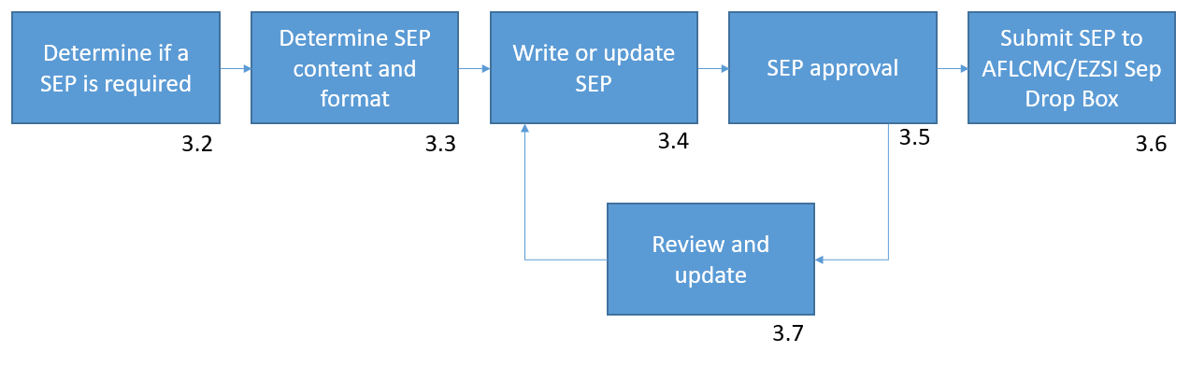

  - Determine if a SEP is required
    - SEPs are required for major capability acquisition programs (any ACAT) and middle tier of acquisition programs.
    - SEPs are a recommended best practice for all other defense system development.
    - SEPs are NOT required for urgent capability acquisition, software acquisition, defense business systems and acquisition of services.
    - DoDI 5000.88, paragraph 3.4.a.(1)(b) describes what programs require SEPs and who should approve them.
    - The AAFDID (reference 2.4.3) is an interactive website that lists the documents programs are required to generate based on acquisition pathway, ACAT and program phase.

  - Determine SEP content and format.
    - Develop the SEP in accordance with the DoD SEP Outline, Version 3.0, dated 12 May 2017. The DoD SEP Outline is available on the DDR&E website, see reference 2.4.2.
      - Technical Certifications, Table 2.2-1. When filling out the technical certifications table in the DoD SEP Outline, consider items listed in the following references:
        - DAFPAM 63-128, Attachment 14
        - DAU Acquisition Program Technical Certifications Summary (reference 2.4.8)
      - Design Considerations, Table 4.4-1. When filling out the design considerations table in the DoD SEP Outline, consider items listed in the following references:
        - DAG, Chapter 3, paragraph 4.3
        - AFI 63-101/20-101 paragraph 5.4.
    - SEP content for MDAPs and ACAT II and III programs can be tailored with approval by the SEP approval authority. Reference 5000.88, paragraph 1.2.b.(1).
    - Include the content described in DoDI 5000.88, paragraph 3.4.1.(3). NOTE: The DOD SEP Outline Version 4.0 dated September 2021 incorporates the DODI 5000.88 SEP content requirements.
    - Include the content described in AFI 63-101/20-101,
      - AFI 63-101/20-101, Paragraph 4.7.4.2. digital product design data
      - AFI 63-101/20-101, Paragraph 4.25.2. IUID planning
      - AFI 63-101/20-101, Paragraph 5.2.2.8.3. deficiency reporting process
      - AFI 63-101/20-101, Paragraph 5.3.3.7. support to maintenance organizations
      - AFI 63-101/20-101, Paragraph 6.2.3. program protection plan
    - Include the content described in AFMCI 63-1201, paragraphs 4.1 and 4.2.
  - Write or update SEP.
    - The SEP is written by the program Chief Engineer (CE) or Lead Systems Engineer (LSE) in support of the Program Manager (PM).
    - The initial SEP for new systems is required at the entry milestone decision point.
  - SEP approval. Programs obtain MDA approval of their SEPs in accordance with AFI 63-101/20-101, paragraph 5.1.3.
  - Submit SEP to AFLCMC/EZSI Systems Engineering Plan (SEP) Drop Box.
    - Submit approved and signed SEPs to the AFLCMC/EZSI SEP Drop Box (reference 2.4.4.) Drop it in the folder corresponding to your PEO.
    - Reference AFMCI 63-1201, paragraph A4.4.
  - Review and update.
    - During development, the SEP shall be updated milestones as specified in the AAFDID (reference 2.4.3).
    - After milestone C, SEPs will be reviewed and updated in accordance with the PEO’s review and approval schedule. Reference AFI 63-101/20-101, paragraph 5.1.3.2.
- Process Audit. The AFLCMC SEP process is monitored using user feedback through the Process Guide Book. Changes addressing user inputs will be incorporated annually along with updates required by changing higher level instructions.

