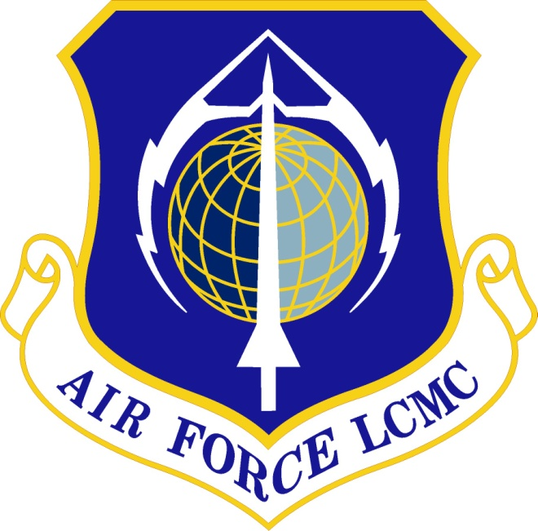

Air Force Life Cycle Management Center (AFLCMC)
Standard Process
For
Spectrum Management in Acquisition Programs

Process Owner: AFLCMC/EZAC (ACQSMO)
Date: 20 Jul 2023
Version: 2.0
Contents
1.0 DESCRIPTION 1
2.0 PURPOSE AND SCOPE 3
3.0 ENTRY/EXIT CRITERIA 3
4.0 PROCESS WORKFLOW AND ACTIVITIES 5
5.0 WORK BREAKDOWN STRUCTURE (WBS) 12
6.0 MEASUREMENT 17
7.0 ROLES AND RESPONSIBILITIES 20
8.0 TOOLS 23
9.0 TRAINING 23
10.0 ACRONYMS, DEFINITIONS, GUIDING PRINCIPLES, GROUND RULES, AND/OR ASSUMPTIONS 24
11.0 REFERENCES TO LAW, POLICY, INSTRUCTIONS OR GUIDANCE 29
12.0 ATTACHMENTS 30

List of Figures
Figure 1. Spectrum Supportability Risk Analysis (link to WBS) 10
Figure 2. Equipment Spectrum Certification Process (link to WBS) 11
Figure 3. Radio Frequency Authorization Process (link to WBS) 11
Figure 4. Host Nation Coordination Process (link to WBS) 12
Figure 5. Spectrum Management for Acquisition Programs 18

List of Tables
Table 1. SIPOC – Spectrum Supportability Risk Assessment 6
Table 2. SIPOC – Equipment Spectrum Certification (ESC) 6
Table 3. SIPOC – Radio Frequency Authorization 8
Table 4. SIPOC – HNC & FD Release 9
Table 5. Spectrum Supportability Risk Assessment (SSRA) WBS 12
Table 6. Equipment Spectrum Certification WBS 13
Table 7. Radio Frequency Authorization (RFA) WBS 14
Table 8. Host Nation Coordination (HNC) and FD Release WBS 16
Table 9. Acronyms List 25

Record of Changes. This page summarizes the changes from each revision to the next. Process numbering starts with 1.0. Minor changes are annotated by changing the second digit, i.e., the first minor change after the basic document would be recorded as “1.1”. Major changes are annotated by changing the first digit, i.e., the first major change after release of the basic document would be numbered as “2.0”.

Record of Changes
Version | Effective Date | Summary
1.0 | 16 Jun 2022 | Initial Document. Approved at 16 Jun 22 SP&P Group
1.1 | 10 Nov 2022 | Fix hyperlink problem on List of Figures. Fix typo on label for Figure 5.
2.0 | 20 Jul 2023 | The changes to this document included adding clarification on the roles and responsibilities of the Acquisition Spectrum Management Office (ACQSMO) in Para 1.4 & 2.1. Updates to entry/exit criteria on all sub-processes in Para 3.0 Updates/clarification to identify funding requirements SIPOC tables in 1 through 4. Updates to improve clarification on roles and responsibilities for ass spectrum stakeholders in tables 5 through 8. Added an additional reference in Para 11. Added most recent version of initial briefing template in Para 12.  Approved at 20 Jul 23 SP&P Group Meeting

Spectrum Management for Acquisition Programs

DESCRIPTION
  - The electromagnetic spectrum is the range of frequencies of electromagnetic radiation extending from zero to infinity, measured in Hertz (Hz), which is a unit of frequency measurement (number of waves that pass by per second). The radio frequency spectrum is the group of frequency sub-bands within the electromagnetic spectrum associated with radio wave propagation between 9 kHz and 3000 GHz. Use of the spectrum is a critical element for mission enabling functions such as communication, navigation, sensing systems and weapons employment. However, the authorization to use spectrum requires an extensive process of validating needs, certifying systems and obtaining authorization prior to use.
  - International law, domestic law, DoD and Federal regulations require effective management and use of the electromagnetic spectrum. Within the United States, the electromagnetic spectrum is allocated between federal and non-federal users with portions of the spectrum being shared as noted in the National Telecommunications and Information Administration (NTIA) Manual National Table of Allocations. The Department of Commerce’s NTIA Manual regulates federal operations, and the Federal Communications Commission regulates non-federal operations. Federal users must utilize frequency bands allocated for government or shared use in accordance with the NTIA Manual. A government frequency assignment can be authorized in a non-government allocated frequency band, provided the Federal Communications Commission or other commercial entities approves the request. Additionally, the identification, management and risk mitigation activities for meeting spectrum requirements are both critical and mandatory functions embedded in the entire acquisition lifecycle. Not addressing spectrum management needs may result in violation of law and significant negative impacts on the cost, schedule, and performance of acquisition programs.
  - Sovereign nations exercise control over the use of the electromagnetic spectrum within their own territory. This basic consideration of international spectrum management becomes extremely important when United States military forces operate abroad. In nearly all circumstances, it is necessary to obtain host nation approval to conduct electromagnetic spectrum operations before United States military forces operate any spectrum-dependent system in a foreign nation. Misuse of spectrum resources or unauthorized electromagnetic spectrum use within a host nation may be a violation of international treaties, international law, or national laws and regulations. Where applicable, assistance from the servicing staff judge advocate or Combatant Command (COCOM) Spectrum Manager with an understanding of international treaties, regulations, and host nation laws will be required.
  - Spectrum Management (SM) for Acquisition Programs is the process used to obtain authorization to use Radio Frequencies (RF) to develop, test and deliver Spectrum Dependent (S-D) systems used in acquisition programs across the Air Force Life Cycle Management Center (AFLCMC) portfolio. This standard process establishes the Acquisition Spectrum Management Office (ACQSMO) as the standard process owner for spectrum management within AFLCMC and the Office of Primary Responsibility (OPR) for providing spectrum management support for acquisition programs. The Standard Process establishes the requirement for Program Offices to program for and provide funding for Spectrum Management support throughout all phases of the acquisition lifecycle to ensure ACQSMO services can be retained when needed. Support from the ACQSMO is obtained through a joint ACQSMO-Program Office process of identify program requirements, development of a work estimate and formal acceptance of a Memorandum of Agreement documenting work requirements, schedule, and cost. ACQSMO support will begin upon acceptance of a funding document. The Standard Process defines prescribed timeline needed to obtain required equipment certifications and frequency assignments. These timelines include the minimum time needed by other Department of Defense and U.S. Government Agencies to process spectrum products and must be followed to ensure spectrum requirements are met.
  - SM for Acquisition Programs consists of four separate but interdependent sub-processes:
    - Spectrum Supportability Risk Assessment (SSRA) – is a regulatory requirement to perform a risk assessment by each acquisition program to identify risk and develop associated mitigation plans as early as possible to affect design and procurement decisions for all S-D systems or platforms hosting S-D systems. Acquisition programs must document and review any identified risks at each milestone decision point as outlined in DoDI 4650.01. SSRAs are also required for modifications to spectrum dependent systems or changes in operational use regardless of which milestone a program is in.
    - Equipment Spectrum Certification (ESC) – is the statutory process by which national regulatory agencies ensure that an S-D system meets the regulatory technical parameters requirements identified in the NTIA Manual or spectrum guidelines/supportability comments received from intended Host Nations (HN). All S-D systems used by the DoD must obtain ESC in accordance with DoD, USAF and national policies identified in para 2.3.
    - Radio Frequency Authorization (RFA) – is the statutory process to obtain a frequency assignment that authorizes operation of a specific S-D equipment at a specific location in accordance with (IAW) NTIA approved equipment certification and/or the Joint Staff J65A United States Military Command, Control, Communications, and Computers Executive Board (MC4EB) guidance.
    - Host Nation Coordination (HNC) – HNC is the requirement to obtain supportability comments (i.e., operating requirements) from Host Nations, via COCOMs. to operate S-D systems in their respective country.
    - Foreign Disclosure (FD) Release - FD Release - is an additional step required specifically for Foreign Military Sale (FMS) projects by which Foreign Disclosure Office (FDO) approval is obtained to release spectrum-related technical data for S-D equipment to foreign nations. Once approved via FDO release, the data is provided to the foreign nation in a releasable format. NOTE: The FD process does not include the steps required to ensure International Traffic in Arms Regulation (ITAR) compliance/licensing which must be accomplished separately.

PURPOSE AND SCOPE
  - Purpose: The purpose of a standardized SM process is to ensure all acquisition programs in AFLCMC effectively, efficiently, and consistently accomplish SM-related tasks for their programs. It establishes the ACQSMO as the OPR for spectrum management within AFLCMC and is the initial point of contact for when engaging external agencies is required. This process also defines the requirement for AFLCMC program offices to identify a Spectrum User Point of Contact (SUPOC) to serve as facilitator (additional duty) for spectrum awareness, training and be the interface between the ACQSMO and Program Office(s) on matters of spectrum management. Furthermore, this process establishes standardized tools and training to enable center-wide adoption, and metrics to support continuous process improvement.
  - Scope: SM has tasks and stakeholders beyond AFLCMC. The scope of this SM process is focused only on the tasks and stakeholders within AFLCMC’s ability to manage, influence and control. While the process focus is internal to AFLCMC, this process does impact the interface with external organizations (e.g., AFMC/A3/6 and the Air Force Spectrum Management Office (AFSMO) within HAF A2/6LS) and these external organizations are referenced herein for completeness. The tasks associated with SM beyond submission of spectrum applications to AFSMO for inter-agency coordination are not within the scope of this document. Further details on that portion of SM is described in DAFI 17-220 and DoDI 8320.05.
  - This document establishes a standard SM process for all acquisition programs in AFLCMC and incorporates guidance from DAFI 17-220, Spectrum Management; Department of Defense Instruction (DoDI) 4650.01, Policy and Procedures for Management and Use of the Electromagnetic Spectrum; DoDI 8320.05, Electromagnetic Spectrum Data Sharing; National Telecommunications and Information Administration Manual of Regulations and Procedures for Federal Radio Frequency Management (hereafter “NTIA Manual”); Air Force Policy Directive (AFPD) 33-5, Warfighting Integration; and the procedures established by the Joint Staff J65A United States MC4EB.

ENTRY/EXIT CRITERIA
  - SSRA Entry Criteria
    - All S-D equipment required for the acquisition program has been identified and its associated risks and mitigation plans documented.
    - Plans to identify, document and resolve Electromagnetic Environmental Effects (E3) are in place or impacts are known and mitigation plans in effect. E3 assessments and associated mitigation efforts will mature during the programs milestones and shall be documented accordingly in SSRA revisions.
    - Standardized Statement of Work (SOW)/Contract Data Requirements List (CDRL) language is on contract with the Prime Contractor when applicable. SOW/CDRL language is hosted on ACQSMO SharePoint site or provided upon requested by ACQSMO.
    - Approved Security Classification Guide (SCG)/Program Protection Plan (PPP) is in place for to protect classified efforts/systems or an approved related system SCG is identified.
    - Initial Spectrum Supportability meeting has been initiated with the ACQSMO and a spectrum support strategy is implemented.
  - SSRA Exit Criteria
    - Milestone Decision Authority (MDA) has approved the SSRA in coordination with SAF/CIO.
  - ESC Entry Criteria
    - All S-D equipment required for the acquisition program has been identified.
    - SSRA complete or in coordination.
    - Standardized SOW/CDRL language is on contract with the Prime Contractor when applicable or required data needed to submit a complete ESC application is made available through other means. SOW/CDRL language shall be hosted on the ACQSMO SharePoint site or provided upon request.
    - Approved program specific SCG/PPP is in place to protect classified programs/systems or an approved related system SCG is identified.
    - If required, Program Management Office (PMO) obtains FDO approval to release spectrum data to foreign nation.
    - Initial Spectrum Supportability meeting has been initiated with ACQSMO and a spectrum support strategy is implemented.
  - ESC Exit Criteria
    - ACQSMO submits ESC application in the End-to-End Supportability System (E2ESS) to next level of review.
    - PMO receives approved ESC from ACQSMO.
  - RFA Entry Criteria
    - All S-D equipment required for the acquisition program has been identified.
    - Operational parameters and locations are provided.
    - Standardized SOW/CDRL language is on contract with the Prime Contractor when applicable. SOW/CDRL language shall be hosted on the ACQSMO SharePoint site or provided upon request.
    - Approved SCG/PPP is in place for to protect classified programs/systems or an appropriate approved system related SCG is identified.
    - Initial Spectrum Supportability meeting has been initiated with ACQSMO and spectrum support strategy is implemented.
    - Approved or under review ESC for equipment is in place at AFMSO.
  - RFA Exit Criteria
    - ACQSMO submits RFA request in Spectrum XXI to AFMC.
    - PMO receives from ACQSMO and RFA approved by the regulating agency.
  - HNC and FD Release Entry Criteria
    - All S-D equipment required for the acquisition program has been identified.
    - Standardized SOW/CDRL language is on contract with the Prime Contractor or required data is already available through other means. SOW/CDRL language shall be hosted on the ACQSMO SharePoint site or provided upon request.
    - ITAR release must be accomplished by PMO prior to submission to the FDO.
    - Approved SCG/PPP is in place to protect to protect classified programs or other appropriate SCGs are identified.
    - Initial Spectrum Supportability meeting has been initiated with ACQSMO and spectrum support strategy is implemented.
    - Approved ESC for equipment is in place depending on host nation certification requirements.
  - HNC and FD Release Exit Criteria
    - FDO approval (foreign disclosure letter) is required before any HNC package is released from AQCSMO.
    - HNC package submitted in E2ESS to AFMC, AFSMO and COCOMs in Host Nation Spectrum Worldwide Database Online (HNSWDO).
    - AFSMO submits RFAs requests for equipment use in HN airspace.
    - HN approval communicated to PMO via ACQSMO.

PROCESS WORKFLOW AND ACTIVITIES
  - Suppliers, Inputs, Process, Outputs, Customers (SIPOC) Table
    - Description
SIPOC Tables identify Suppliers, the Inputs they provide to a process step/activity, the Process Step/Activity that receives those inputs, the Outputs of those activities, and the Customers of those outputs. As such, they provide a summary of major process activities that will be necessary to produce the desired products and permit exiting the process. The process activities can be read in order down the center column of the table. They assume success at each step and are an easy-to-understand picture of the process in tabular form. The party responsible for performing the process step in one row becomes the supplier in the next, the outputs of their process steps become the input on the next row, and the customer at the end of one row becomes the party responsible for performing the process activities shown in the next row.

Table 1. SIPOC – Spectrum Supportability Risk Assessment
Suppliers | Inputs | Process | Outputs | Customers
PMO, ACQSMO | ACQSMO provides initial overview briefing on SM process and training when required & SSRA format and examples.  PMO identifies spectrum requirements (SSRA, ESC, RFA, HN) using standard Initial Briefing Template | Conduct Spectrum Supportability Meeting to develop Spectrum Management support plan | Final PMO briefing and meeting minutes  ACQSMO provides Spectrum Support Plan, Government Work Estimate (GWE), & Memorandum of Agreement (MOA)  PMO provides funding document | PMO, DOE, SUPOC, and ACQSMO
PMO, Prime Contractor | S-D Requirement(s)  SSRA based on S-D risks to the program with mitigation plans | ACQSMO, AFMC A3/6, AFSMO, SAF CIO review, provide feedback, and coordinate on PMO submission of SSRA | MDA approval of SSRA based on SAF/CIO recommendation | PMO

Table 2. SIPOC – Equipment Spectrum Certification (ESC)
Suppliers | Inputs | Process | Outputs | Customers
PMO, ACQSMO | ACQSMO initial overview briefing on SM process  PMO identified spectrum requirements (SSRA, ESC, RFA, HNC) using standard Initial Briefing Template or any other mutually-agreeable means to convey needed data | Conduct Spectrum Supportability Meeting to develop Spectrum Management support plan | Final PMO briefing and meeting minutes  ACQSMO provides Spectrum Support Plan, GWE, & MOA  PMO provides funding document | PMO, ACQSMO, SUPOC
Prime Contractor when applicable | Design, engineering, and calculated/measured test data on Equipment Spectral and Spatial Characteristics depending on ESC stage. (data needed to acquire approved/signed NTIA certification) | Develop and submit Equipment Spectral and Spatial Characteristics to PMO | Equipment Spectral and Spatial Characteristics IAW contract requirements | PMO
PMO, SUPOC | Equipment Spectral and Spatial Characteristics in format acceptable to ACQSMO (e.g., Equipment Location-Certification Information Database ( EL-CID), Stepstone) | Submit Equipment Spectral and Spatial Characteristics to ACQSMO | Equipment Spectral and Spatial Characteristics submitted to ACQSMO | ACQSMO
ACQSMO | PMO submitted Equipment Spectral and Spatial Characteristics | Convert Equipment Spectral and Spatial Characteristics data into E2ESS application. Resolve any issues with PMO before submission | ESC submission to AFMC/A3/6 in E2ESS | AFMC/A3/6
AFMC/A3/6 | ACQSMO-submitted ESC application in E2ESS | Review and resolve issues with ACQSMO before release of submission | ESC submission to AFSMO in E2ESS | AFSMO
AFSMO | AFMC submitted ESC application in E2ESS | Review/resolve any issues with AFMC and/or ACQSMO before submission | ESC submission to external agency coordination and resolution in E2ESS | External Agencies (e.g., Federal Aviation Administration (FAA), NTIA)

Table 3. SIPOC – Radio Frequency Authorization
Suppliers | Inputs | Process | Outputs | Customers
PMO, ACQSMO | ACQSMO provides initial overview briefing on SM process  PMO identifies spectrum requirements (SSRA, ESC, RFA, HNC, FD) using standard Initial Briefing Template or any other mutually-agreeable means to convey needed data | Conduct Spectrum Supportability Meeting to develop Spectrum Management support plan | Final PMO briefing and meeting minutes  ACQSMO provides Spectrum Support Plan, GWE, & MOA  PMO provides funding document | PMO, ACQSMO, SUPOC
Prime Contractor when applicable | Design, engineering, and test data on planned Equipment Operating Parameters as needed to support RFA submission. | Develop and submit planned Equipment Operating Parameters to PMO | Planned Equipment Operating Parameters | PMO
PMO, SUPOC | Ensure ESC in place  Planned Equipment Operating Parameters | Develop and submit RFA worksheet (or have prime contractor do so) to ACQSMO | Submitted RFA Worksheet to ACQSMO | ACQSMO
ACQSMO | PMO-submitted RFA worksheet | Review and provide quality check on worksheet contents. Resolve any issues with PMO. Transfer worksheet contents into Standard Frequency Action Format (SFAF). Submit SFAF application into Spectrum XXI | SFAF submission to AFMC/A3/6 in Spectrum XXI | AFMC/A3/6
AFMC/A3/6 | ACQSMO submitted SFAF application in Spectrum XXI | Review and resolve any issues with ACQSMO before release of submission | SFAF application submission to AFSMO in Spectrum XXI | AFSMO
AFSMO | HQ AFMC released SFAF application in Spectrum XXI | Review and resolve any issues with HQ AFMC and/or ACQSMO before release to AFSMO | SFAF application release to external agency coordination | External Agencies (e.g., NTIA)

Table 4. SIPOC – HNC & FD Release
Suppliers | Inputs | Process | Outputs | Customers
PMO, ACQSMO | ACQSMO initial overview briefing on SM process  PMO-identified spectrum requirements (SSRA, Cert, RFA, HNC, FD) using standard Initial Briefing Template | Conduct Spectrum Supportability Meeting to develop Spectrum Management support plan | Final PMO briefing and meeting minutes  ACQSMO provides Spectrum Support Plan, GWE, & MOA  PMO provides funding document | PMO, ACQSMO
PMO, ACQSMO | ESC and program SCG/PPP in place | PMO applies SCG and data analysis to determine releasability, ITAR compliance and compose FDO package with assistance of ACQSMO | Package for FDO Submission | FDO
Foreign Disclosure Office | ESC and SCG  FDO package submitted by ACQSMO | FDO Analysis | FDO Approval | PMO
PMO, ACQSMO | ESC and FDO Approval | PMO develop HN package; ACQSMO reviews for accuracy, completeness | Submit HN package | AFSMO, COCOMs, Foreign Nations for FD Release

  - Process Flowcharts
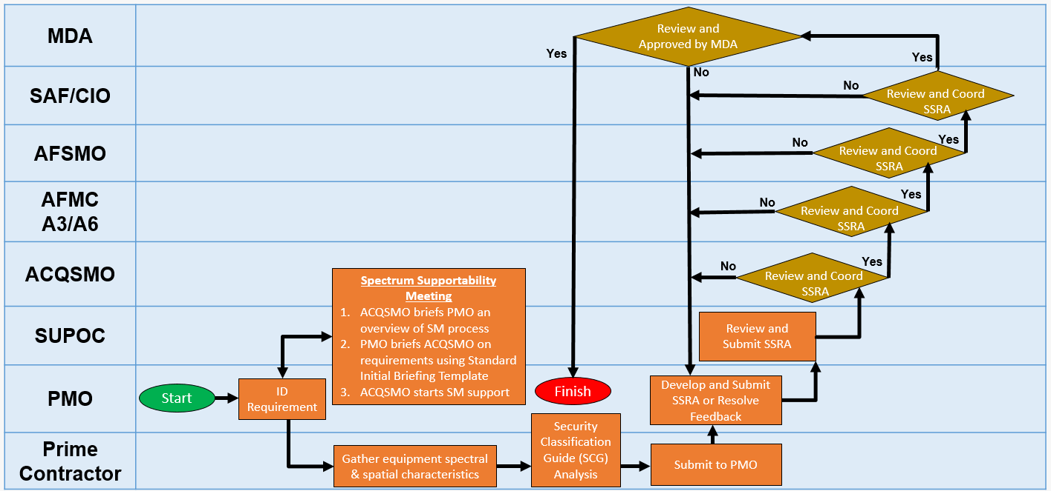
Figure 1. Spectrum Supportability Risk Analysis (link to WBS)

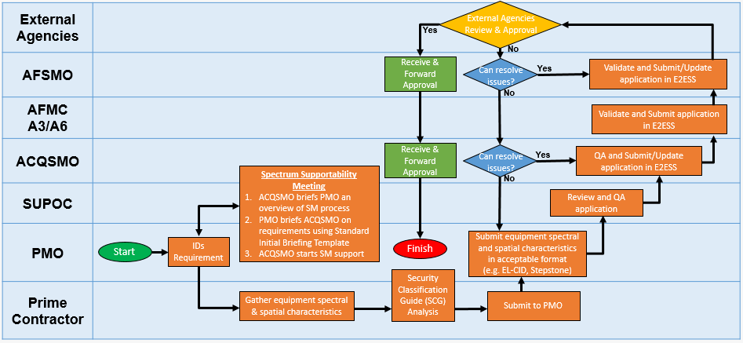
Figure 2. Equipment Spectrum Certification Process (link to WBS)
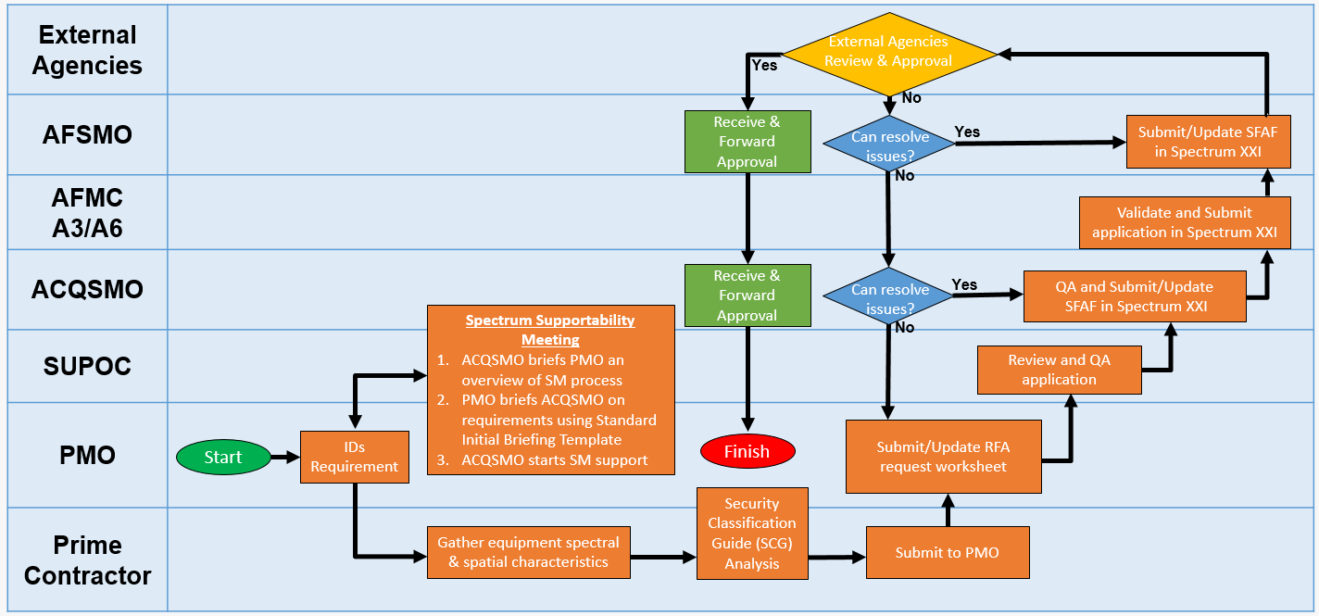
Figure 3. Radio Frequency Authorization Process (link to WBS)

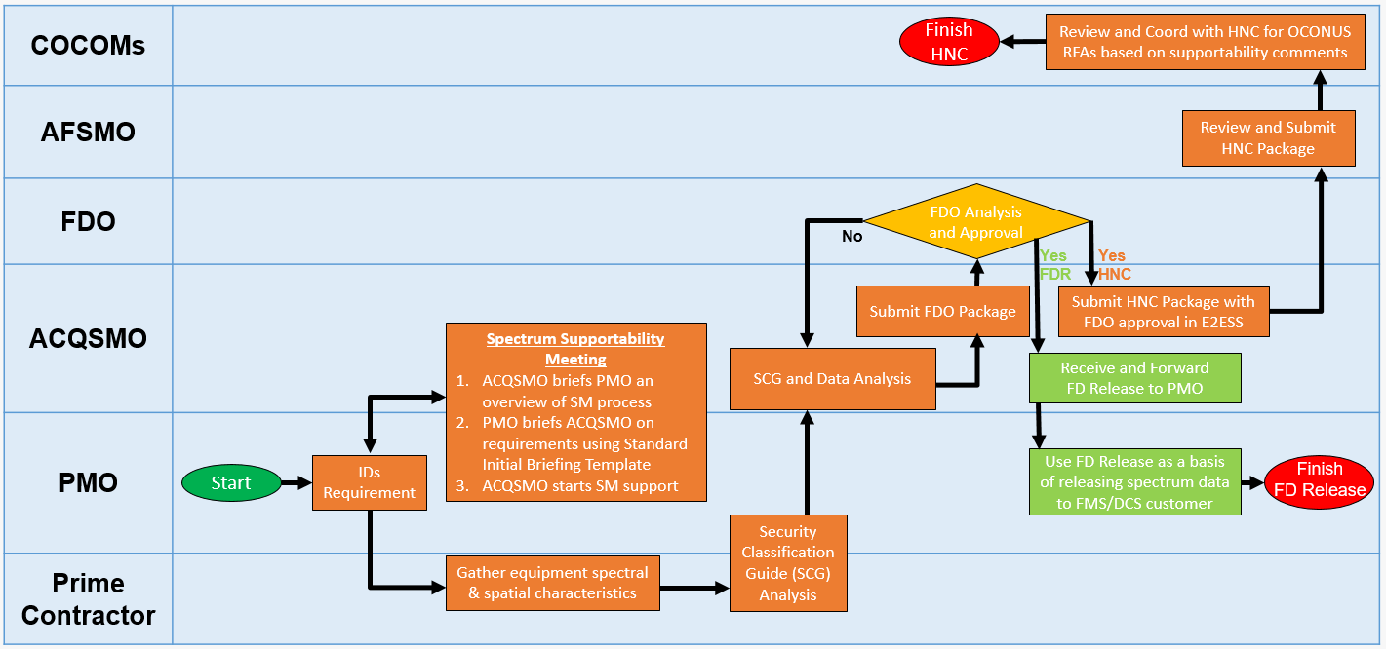
Figure 4. Host Nation Coordination Process (link to WBS)

WORK BREAKDOWN STRUCTURE (WBS)

Table 5. Spectrum Supportability Risk Assessment (SSRA) WBS
WBS | Activity | Description | OPR
1. | Spectrum Supportability Meetings | Once the PMO identifies SM requirements, they shall initiate a meeting with the ACQSMO. At this meeting, the ACQSMO shall brief the PMO on the overview of the spectrum management process and organizational responsibilities. The PMO is provided a standardized initial briefing template which they must fill out and provide to ACQSMO prior to initial meeting. This briefing template will capture the program’s SM requirements (SSRA, ESC, RFA, and FD/HNC as applicable) and schedule need dates (i.e. test, delivery) so ACQSMO can assess scheduling risks and prioritize workload. The minutes/template from this meeting will serve as the baseline spectrum requirements to develop the ACQSMO support for the PMO. The ACQSMO will deliver a draft MOA and a GWE. A signed MOA and funding document is required prior to start of work. | PMO, SUPOC, ACQSMO
2. | Gather spectral and spatial requirements for S-D systems | The PMO shall request spectrum data from the Prime Contractor through proper contractual arrangements for all S-D equipment or provide data if already available. The Prime Contractor/PMO will gather all the spectral and spatial characteristics for all S-D equipment on the system. | Prime Contractor, PMO
3. | Accomplish SCG & Data Analysis | The PMO shall accomplish a SCG analysis, with support of the contractor, if necessary, to determine which aspects of the spectral characteristics of the S-D equipment are classified or require additional protection IAW SCG or PPP. In addition, the PMO should determine the foreign disclosure considerations and intellectual property tied to the requirements. | Prime Contractor, PMO
4. | Develop SSRA | The PMO will develop the SSRA to identify all spectrum dependent requirements, systems and risks as early as possible that may affect design and procurement decisions for all S-D systems. The SSRA is reviewed, updated and coordinated for approval at each milestone decision point or major system change or new operational employment as outlined in DoDI 4650.01. | PMO
5. | Review, coordinate, and provide feedback on SSRA | The coordination for the SSRA will include several stakeholders including SUPOCs, ACQSMO, AFMC/A3/6, AFSMO, and SAF CIO. Each of stakeholder shall review and provide feedback to the PMO to make sure the spectrum risks are adequately captured, tracked, and have a mitigation strategy to obtain needed spectrum certification and authority to operate spectrum dependent systems . | PMO, SUPOC,  ACQSMO, AFMC/A3/6, AFSMO, SAF CIO
6. | Approve SSRA | The MDA for the acquisition program approves the SSRA in coordination with SAF/CIO. | MDA

Table 6. Equipment Spectrum Certification WBS
WBS | Activity | Description | OPR
1. | Spectrum Supportability Meetings | Once the PMO identifies a SM requirement, they shall initiate a meeting with the ACQSMO. At this meeting, the ACQSMO will brief the PMO on an overview of the spectrum support process and organizational responsibilities. The PMO is provided a standardized initial briefing template which they must fill out and provide to ACQSMO prior to the initial meeting. This briefing template will capture the SM requirements (SSRA, ESC, RFA, and FD/HNC as applicable) and schedule need dates so ACQSMO can assess scheduling risk and prioritize workload. The minutes/slide template from this meeting will serve as the baseline spectrum requirements to develop the ACQSMO support for the PMO. The ACQSMO will deliver a draft MOA and a GWE. A signed MOA and funding document is required prior to start of work. | PMO, ACQSMO
2. | Gather spectral and spatial requirements for S-D systems | The PMO shall request spectrum data from the Prime Contractor through proper contractual arrangements for all S-D equipment or provide data if already available. The Prime Contractor/PMO will gather all the spectral and spatial characteristics for all S-D equipment on the system. | Prime Contractor, PMO
3. | Accomplish SCG & Data Analysis | The PMO will accomplish a SCG analysis, with support of the contractor, if necessary, to determine which aspects of the spectral characteristics of the S-D equipment are classified or required additional protection IAW SCG or Program PPP. In addition, the PMO should determine the foreign disclosure considerations and intellectual property tied to the requirements. | Prime Contractor, PMO
4. | Compile and submit ESC Application | The PMO compiles the equipment spectral and spatial characteristics and submits them in an acceptable format to ACQSMO. The PMO has the ultimate responsibility for providing all data necessary for meeting ESC/certification guidelines. ACQSMO develops and submits the ESC application in a format acceptable to AFSMO/NTIA/SPS | PMO, ACQSMO
5. | Review and Coordinate ESC application | The coordination of the ESC application will include AFMC/A3/6, and AFSMO. Each stakeholders shall review and provide feedback to the ACQSMO. The ACQSMO shall work with the PMO to adjudicate comments/findings and ensure all updates a are in the right format and includes the spectral and spatial characteristics meets the requirements in the NTIA manual. | ACQSMO, AFMC/A3/6, AFSMO
6. | Receive ESC Approval | AFSMO is the single point of contact for external agency review/approval of ESC applications. Once external agencies have reviewed the application, AFSMO receives the approval or disapproval. AFSMO also serves as the single point of contact for the Air Force to coordinate and respond to feedback from external agencies. AFSMO will coordinate responses to external agency feedback through AFMC/A3/6. Once all comments from external agencies have been resolved, AFSMO receives ESC approval which is then forwarded to AFMC/A3/6, ACQSMO, and finally the PMO. | NTIA, MC4EB,  AFSMO,  ACQSMO,  PMO

Table 7. Radio Frequency Authorization (RFA) WBS
WBS | Activity | Description | OPR
1. | Spectrum Supportability Meetings | Once the PMO identifies SM requirements, they shall initiate a meeting with the ACQSMO. At this meeting, the ACQSMO will brief the PMO on the overview of the spectrum management process and organizational responsibilities. The PMO is provided a standardized initial briefing template which they must fill out and provide to ACQSMO prior to the meeting. This briefing template will capture the program’s SM requirements (SSRA, ESC, RFA, and FD/HNC as applicable) and schedule need dates (i.e. test, delivery) so ACQSMO can assess scheduling risks and prioritize workload. The minutes/template from this meeting will serve as the baseline spectrum requirements to develop the ACQSMO support plan for the PMO. The ACQSMO will deliver a draft MOA and a GWE. A signed MOA and funding document is required prior to start of work. | PMO, ACQSMO
2. | Gather spectral and spatial requirements for S-D systems | The PMO shall request spectrum data from the Prime Contractor through proper contractual arrangements for all S-D equipment or provide data if already available. The Prime Contractor/PMA will gather all the spectral and spatial characteristics for all S-D equipment on the system. | Prime Contractor, PMO
3. | Accomplish SCG Analysis | The PMO will accomplish a SCG analysis, with support of the contractor, if necessary, to determine which aspects of the spectral characteristics of the S-D equipment are classified or require additional protection IAW SCG or PPP | Prime Contractor, PMO
4. | Compile RFA Application | The PMO compiles the RFA application via a frequency request worksheet developed/provided by ACQSMO. The worksheet must contain required Equipment Spectral and Spatial Characteristics and the planned operating parameters. The PMO then submits the worksheet to the ACQSMO. | PMO
5. | Compile, Review, Coordinate, and Submit RFA application | The ACQSMO converts the PMO-supplied frequency request worksheet into an RFA application in Spectrum XXI. The application is coordinated with AFMC/A3/6 and AFSMO. These offices review and provide feedback to the ACQSMO. The ACQSMO will work with the PMO to adjudicate comments and ensure updated RFA application is correctly formatted and contains all required data. | ACQSMO, AFMC/A3/6, AFSMO
6. | Receive RFA Approval | AFSMO is the single point of contact for coordinating external agency review of RFA applications. Once external agencies have reviewed the application, AFSMO receives the approval or disapproval. AFSMO serves as the single point of contact for the Air Force to coordinate and respond to feedback from external agencies. AFSMO will coordinate responses to external agency feedback through AFMC/A3/6. Once all comments from external agencies have been resolved, AFSMO receives the RFA approval which is then forwarded to AFMC/A3/6, ACQSMO, and finally the PMO. | External Agencies (FAA, NTIA, MC4EB)

Table 8. Host Nation Coordination (HNC) and FD Release WBS
WBS | Activity | Description | OPR
1. | Spectrum Supportability Meetings | Once the PMO identifies SM requirements, they shall initiate a meeting with the ACQSMO. At this meeting, the ACQSMO will brief the PMO on an overview of the process. The SPO is provided a standardized initial briefing template which they must fill out and provide to ACQSMO. This briefing template will capture the SM requirements (SSRA, ESC, RFA, and FD/HNC as applicable) and schedule need dates so ACQSMO can prioritize workload and start spectrum support for the PMO. The minutes from this meeting will serve as the baseline spectrum requirements to develop the ACQSMO support p for the PMO. The ACQSMO will deliver a draft MOA and a GWE. A signed MOA and funding document is required prior to start of work. | PMO, ACQSMO
2. | Gather spectral and spatial requirements for S-D systems | The assumption here is that the PMO has requested spectrum data from the Prime Contractor through proper contractual language for all S-D equipment on the system. The Prime Contractor will gather all the spectral and spatial characteristics for all S-D equipment on the system. | Prime Contractor, PMO
3. | SCG & Data Analysis | The Prime Contractor in conjunction with the PMO will accomplish a SCG analysis to determine which aspects of the spectral characteristics of the S-D equipment are classified. Once this has been accomplished, the assessment is passed to ACQSMO who submits the HN package to the FDO for analysis and FDO approval. | PMO, ACQSMO
4. | Foreign Disclosure Analysis | The Foreign Disclosure Office performs an analysis to review the HN package before the release of information requiring disclosure of classified or export-controlled unclassified, including sensitive unclassified information. The FDO will provide an approval or disapproval of the package and coordinate any feedback to ACQSMO. If disapproved, modify, and resumbmit | FDO
5. | FD Release (if required) | Once the FDO approval is received, ACQSMO forwards the FDO release to the PMO. The data can then be provided to the FMS customer in a releasable format, if required. | PMO (FMS)
6. | HN Package Development and Submission | Once the FDO approval is received, ACQSMO includes FDO approval with the HN Package and submits it for HNC in E2ESS. | ACQSMO,  AFMC/A3/6,
7. | HN Coordination | HN(s) provide(s) comments in response to the HN request, ACQSMO and PMO review HN comments received for operational restrictions posed by HN(s) on S-D equipment use in HN airspace. COCOMs and MAJCOMs submit RFAs for equipment use in Host Nation airspace. | AFMC/A3/6, ACQSMO,  MAJCOMs  COCOMs

MEASUREMENT
  - Process Results. This section contains guidance and directions on how the process results will be measured via a SMART Metric. Metrics used to measure this process performance including acceptability of utilizing the Metric Attribute Template will be described to include any metrics used while performing this process to manage the process. It is important to establish schedule and timeline threshold and object goals that will be required to regularly analyze, report, and act upon the SM process and its outcomes. Only the PMO Compliance Metrics in section 6.1.1 will be captured in the SMART Metric in Attachment 11 and will be briefed at the SP&P annually. The remaining metrics in section 6.1.2, 6.1.3, and 6.1.4 will be tracked internally by ACQSMO Contract Support.
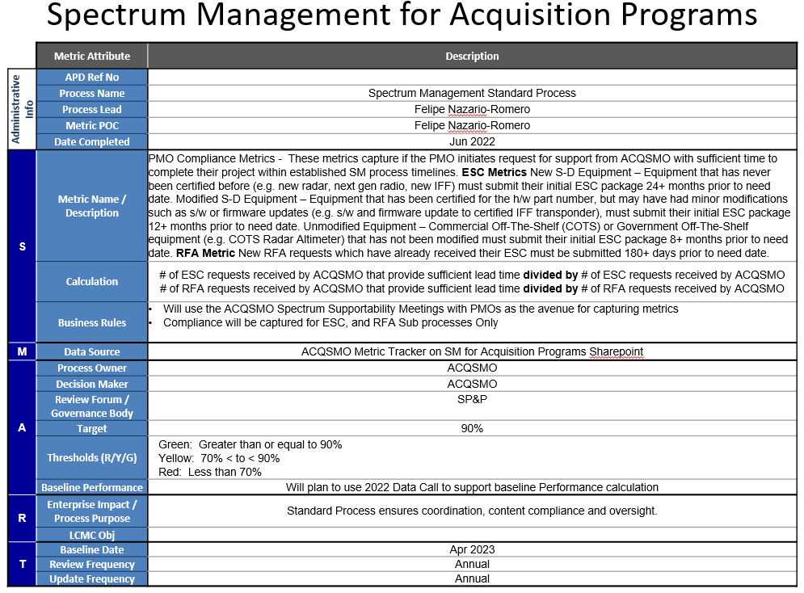
    - PMO Compliance Metrics – These metrics for ESCs and RFAs capture whether the PMO initiates request for support from ACQSMO with sufficient time to complete their project within SM process timelines given below.
Figure 5. Spectrum Management for Acquisition Programs
      - Equipment Spectrum Certification Submission Requirements
        - New S-D Equipment – Equipment that has never been certified before (e.g., new radar, next gen radio, new IFF) must submit their complete ESC package 24+ months prior to need date.
        - Modified S-D Equipment – Equipment that has been certified for the hardware part number but may have had minor modifications such as software or firmware updates (e.g., software and firmware update to certified IFF transponder), must submit their complete ESC package 12+ months prior to need date.
        - Unmodified Equipment – Commercial Off-The-Shelf (COTS) or Government Off-The-Shelf equipment (e.g., COTS Radar Altimeter) that has not been modified must submit their complete ESC package 8+ months prior to need date.
      - Radio Frequency Authorization (RFA) Submission Requirements
        - New RFA requests which have already received an approved ESC must be submitted 180+ days prior to need date after receipt of approved ESC or submittal to SPS.

    - Spectrum Supportability Risk Assessment (SSRA)
      - % of SSRA submissions from PMO to ACQSMO returned for rework due to
        - Incomplete information
        - Incorrect information
      - % of SSRA submissions from ACQSMO to reviewing stakeholders returned for rework due to
        - Incomplete information
        - Incorrect information
      - Time for SSRA approval from ACQSMO submission to SAF/CIO approval**
    - Equipment Spectrum Certification (ESC)
      - % of ESC application submissions from PMO to ACQSMO returned for rework due to:
        - Incomplete information
        - Incorrect information
      - % of ESC application submissions from ACQSMO returned for rework due to
        - Incomplete information
        - Incorrect information
      - Time for ESC coordination for the following activities:
        - Initial PMO/ACQSMO meeting to PMO submission of S-D equipment data required for ESC application development by ACQSMO
        - ACQSMO reception of ESC application in E2ESS to submission to HQ AFMC in E2ESS
        - HQ AFMC reception of ESC application in E2ESS to submission to AFSMO in E2ESS
        - AFSMO reception of ESC application in E2ESS to submission to External Agency Review**
        - AFSMO submission of ESC application in E2ESS to receipt of NTIA approval**
        - NTIA approval to receipt of MC4EB Guidance**
    - Radio Frequency Authorization (RFA)
      - % of RFA worksheet submissions from PMO to ACQSMO returned for rework due to
        - Incomplete information
        - Incorrect information
      - % of RFA application submissions from ACQSMO returned for rework due to
        - Incomplete information
        - Incorrect information
      - Time for RFA coordination for the following activities:
        - Initial PMO/ACQSMO meeting to PMO submission of RFA worksheet request
        - ACQSMO reception of PMO RFA worksheet request to SFAF submission in Spectrum XXI
        - AFMC reception of ACQSMO RFA application in Spectrum XXI to SFAF submission in Spectrum XXI
        - AFSMO reception of AFMC RFA application in Spectrum XXI to SFAF submission in Spectrum XXI**
        - AFSMO submission in Spectrum XXI to receipt of NTIA approval**

** Note: These metrics are outside the purview of AFMC/AFLCMC and are tracked for the purposes of providing feedback to agencies outside AFMC

ROLES AND RESPONSIBILITIES
  - Process Owner - Acquisition Spectrum Management Office (ACQSMO)
    - Maintains and coordinates changes to this Standard Process.
    - Leads and/or assigns personnel to work on any process improvement and change events related to this process.
    - Ensures proper application of policy and procedures IAW DoD and Federal directives & policies
    - Track and maintains a list of ESC and RFAs, and provides periodic status reports to the requesting office.
    - Trains and equips spectrum managers on Spectrum Management Process and Spectrum Management Information Technology applications.
    - Organizes and conducts quarterly Spectrum User POC (SUPOC) Working Group (SUPOC-WG) to address AFLCMC-wide spectrum management issues and serves as chairperson(s) of the SUPOC-WG, which provides a forum to exchange spectrum status updates and spectrum related guidance with SUPOCs.
    - Supports PMOs in development and submission of Spectrum Management products (SSRA, ESC, RFA, and FD/HNC).
    - Develops and maintains templates for Key Foundational Documents (e.g., PMO Initial Kickoff briefing template, standard SOW/CDRL language, SSRA template).
    - Collects and records SM process metrics per Section 6.
    - Accomplishes required Level I, II, and III (available 3 Qtr CY23) Spectrum Training
    - Maintains an on-line repository for briefing templates, process documents, training and support tools
  - Air Force Spectrum Management Office (AFSMO) (HAF/A2/6LS)
    - Submits ESC applications from AFMC/A3/6 to NTIA for review and approval.
    - Submits RFA applications from AFMC/A3/6 to NTIA for review and approval.
    - Provides external agency feedback on spectrum applications to AFMC/A3/6.
    - Coordinates and provides feedback on SSRAs.
  - Air Force Materiel Command (AFMC) A3/6
    - Submits ESC applications from ACQSMO to AFSMO for review and approval.
    - Submits RFA (SFAF) applications from ACQSMO to AFSMO for review and approval.
    - Coordinates and provides feedback on SSRAs.
    - Trains and equips spectrum personnel across the MAJCOM.
  - Foreign Disclosure Office (FDO) (AFLCMC/WF)
    - Accomplishes Foreign Disclosure analysis and coordinates on HNC packages.
    - Accomplishes Foreign Disclosure Release for FMS.
    - Accomplishes Foreign Disclosure Release HNC packages.
  - Program Executive Offices (PEO) / Directors of Engineering (DOE)
    - Ensure a primary and alternate Spectrum User Point of Contact (SUPOC) is assigned for each directorate to support quarterly meetings with ACQSMO.
    - Ensure awareness of prioritization needs for spectrum approvals within the directorates.
    - Create and maintain an updated list of all S-D equipment used within their respective directorates.
    - Complete Level I Spectrum Training provided by ACQSMO.
  - Spectrum User Points of Contact (SUPOC)
    - Maintain awareness of all spectrum requirements and priorities for all programs in their respective directorates or assigned area of responsibility.
    - Attend Spectrum Supportability Meetings between ACQSMO and individual programs.
    - Provide status updates and prioritization for “in-work” and “upcoming” spectrum needs for programs in the directorate at the Quarterly SUPOC-WG meetings hosted by ACQSMO.
    - Complete required Level I, II, and III Spectrum Training provided by ACQSMO.
  - Program Management Offices (PMO)
    - Obtain spectrum certification support or develop an acquisition strategy with spectrum management support prior to purchasing S-D systems or entering into any contractual obligations for the use of spectrum-dependent devices in accordance with the NTIA Manual, paragraph 10.1.2 and DoDI 4650.01.
    - Obtain frequency assignments through ACQSMO prior to operation of any spectrum-dependent devices that radiate radio frequency energy per NTIA Manual.
    - Ensure S-D system operations comply with authorized parameters identified in frequency assignment notifications.
    - Ensure sufficient schedule and funding is available to obtain support through ACQSMO per Section 10.2.
    - Develop and submit SSRAs for S-D systems for their respective programs.
    - Maintain copies of ESCs and RFAs received from the ACQSMO.
    - Ensure standardized SOW/CDRL language provided by ACQSMO is on applicable contracts with the Prime Contractors when developing, procuring or modifying S-D systems. SOW/CDRL language shall be posted on the ACQSMO SharePoint site or provide by ACQSMO upon request.
    - Ensure the Prime Contractors provide all necessary spectrum-related data for spectrum applications.
    - Ensure PMO Spectrum Points of Contact are assigned.
    - Ensure SM status and risks are captured in acquisition decision briefings (e.g., Milestone Gate Reviews, System Engineering Technical Review (SETR) Gate templates, Enhanced Information Support Plan (EISPs), Acquisition Strategy Panel (ASPs), etc.)
    - Ensure program schedules accommodate SM processing timelines.
    - Maintain a list of all S-D equipment, supporting configuration management efforts for the DoE and the SUPOCs.
    - All personnel within the PMO involved with S-D equipment should complete the Level I Spectrum Training provided by ACQSMO.
  - PMO PMs/ENs supporting S-D related programs
    - Accomplish mandatory spectrum training per Section 9.1.
    - Ensure all ESC and RFA applications comply with SM standard process requirements.
    - Provide updated lists of S-D equipment used within the program to SUPOCs.
    - Provide status updates and spectrum needs to SUPOCs in support of the Quarterly Spectrum Management Working Group (SMWG) meetings hosted by ACQSMO.
    - Complete required Level I, II, and III Spectrum Training as applicable.

TOOLS
  - Stepstone Editor – is an online tool used to generate ESC requests. This tool is an option for PMOs to present ECS data to ACQSMO for processing. Spectrum certification requests may be submitted in Standard Spectrum Resource Format (SSRF) format as generated by the latest Stepstone Editor. Please use the following link to access the latest version of the Editor: https://www.stepstoneeditor.com/. PMOs may submit equipment certification information to the ACQSMO in alternative formats (e.g., DD 1494, EL-CID), but eventually such data must be transcribed into E2ESS.
  - E2ESS - provides a data collection tool and database for spectrum supportability business processes. E2ESS is only available to training/certified spectrum managers. It also provides worldwide visibility of HN S-D equipment’s supportability. E2ESS integrates and consists of both Stepstone and Host Nation Spectrum Worldwide Database Online (HNSWDO) capabilities. Access to E2ESS is controlled.
  - Spectrum XXI - is a joint tool for the DoD to manage the spectrum of radio frequencies. It provides frequency managers with a single information system that addresses spectrum management automation requirements. SXXI supports DoD planning and operations with: frequency management workflow capabilities, radio frequency (RF) engineering analyses, data validation, and regulatory compliance checks and visualization tools. SXXI resides on the Secret Internet Protocol Router Network (SIPRNet) and is accessible only by full-time spectrum managers who have received the necessary training. The database associated with SXXI is classified. Access is controlled and only available to trained and vetted spectrum managers.

TRAINING
  - Method
    - Overview: AFLCMC SM training will leverage spectrum education from AFMC as well as AFLCMC to educate personnel at various echelons from spectrum managers to acquisition leaders. Training on the SM process will enable PMOs to meet USAF demands for effective and compliant systems fielded on accelerated development timelines.
    - Training Methods: AFLCMC SM Training will involve in-person, online, briefing, and classroom delivery schemes. Training will be incorporated into the Spectrum Management Class conducted quarterly as part of AFLCMC Focus Week as well as other forums. This standard process document will be referenced in training materials and be accessible via the AFLCMC Process Directory (APD): https://usaf.dps.mil/teams/21710/gov/APDSP/Forms/AllItems.aspx
    - Levels of Spectrum Training:
      - Level I: General Introductory Overview – this training provides a basic understanding of SM process. The target audience for this class is anyone, but especially spectrum users, SPMs, PMs, and PEOs.
      - Level II: SM for Acquisition Programs – this training provides a greater understanding of the SM process for acquisition programs as well as specific topics of interest to include: an overview of SM IT systems, Data requirements for submitting SSRAs, ESCs, RFAs, HNC and FD Release, as well as Center specific process and practices. The target audience for this training is anyone who has spectrum equipment and working toward spectrum compliance to include: PMs, CEs, SUPOCs, PMO ENs etc.
      - Level III: SM Technical Deep Dive (in development) - A more detailed level course covering SM requirements for the practitioner. This level of training will be targeted towards anyone having technical involvement in the equipment certification and frequency authorization sub-processes. Training will include better familiarization with development of technical (spectral and spatial) data, working with SM Information Technology systems (E2ESS, SXXI) and navigating FD/HNC processes.
      - Level IV: Equipment Certifier Training (To Be Developed) - A more detailed level course focused on developing and training Equipment Certifiers. Some of the content in the course will include RF technical fundamentals, communication theory, detailed IT systems training in E2ESS (Stepstone, EL-CID), submission and approval process details etc.
  - Change Management Plan. Use the template at Attachment 2 to document the plan for implementing and institutionalizing your standard process. Describe or reference the attachment here.

ACRONYMS, DEFINITIONS, GUIDING PRINCIPLES, GROUND RULES, AND/OR ASSUMPTIONS
  - Acronyms
Table 9. Acronyms List
ACQSMO | Acquisition Spectrum Management Office
ASP | Acquisition Strategy Panel
AFNWC | Air Force Nuclear Warfare Center
AFSMO | Air Force Spectrum Management Office
COCOM | Combatant Command
COTS | Commercial Off-The-Shelf
CDRL | Contract Data Requirements List
DoD | Department of Defense
E2ESS | End-to-End Supportability System
EISP | Enhanced Information Support Plan
EL-CID | Equipment Location-Certification Information Database
ESC | Equipment Spectrum Certification
FCC | Federal Communications Commission
FDO | Foreign Disclosure Office
FMS | Foreign Military Sales
GOTS  GWE | Government Off-The-Shelf  Government Work Estimate
HNC | Host Nation Coordination
HNSWDO | Host Nation Spectrum Worldwide Database Online
ITAR | International Traffics in Arms Regulation
MC4EB | Military Command, Control, Communications, and Computers Executive Board
MDA | Milestone Decision Authority
MIPR  MOA | Military Interdepartmental Purchase Request  Memorandum Of Agreement
NTIA | National Telecommunications and Information Administration
PMO | Program Management Office
RFA | Radio Frequency Authorization
SIPRNet | Secret Internet Protocol Router Network
SCG | Security Classification Guide
S-D | Spectrum Dependent
SETR | System Engineering Technical Review
SFAF | Standard Frequency Action Format
SIPOC | Suppliers, Inputs, Process, Outputs, Customers
SM | Spectrum Manager
SMWG | Spectrum Management Working Group
SOW | Statement of Work
SSRA | Spectrum Supportability Risk Assessment
SUPOC | Spectrum User Point of Contact
SXXI | Spectrum XXI
WBS | Work Breakdown Structure

  - Definitions
Commercial Off-the-Self (COTS) – A commercial item sold in large amounts in the commercial market and accessible to the government under a contract or subcontract at any tier, deprived of any modification, in the same configuration in which it was sold.
Contract Data Requirements List (CDRL): List of authorized data requirements for a specific procurement that forms part of a contract and identifies specific data requirements/products that must be delivered to the Government by the contractor.
DD Form 1494 – This form is obsolete but the term is used interchangeably with equipment certification documents. It is the original form used to create an application for spectrum certification. An .xml file and a .cid file which are in use for this purpose today can be printed out in DD Form 1494 format.
End-to-End Supportability System (E2ESS) - E2ESS provides a data collection tool and database for spectrum supportability business processes. It provides worldwide visibility of host nation spectrum-dependent equipment’s supportability. E2ESS integrates Stepstone and Host Nation Spectrum Worldwide Database Online (HNSWDO) capabilities. Access to E2ESS is controlled.
Equipment Location-Certification Information Database (EL-CID) – A software program for a user to provide required information to create an application for spectrum certification.
Equipment Spectrum Certification (ESC) –The statutory process by which national regulatory agencies ensure that an S-D system meets the regulatory technical parameter requirements authorized within NTIA Manual or spectrum guidelines/supportability comments from intended Host Nations (HN).
FCC – The Federal Communications Commission is the entity who handles State, Local Government, Commercial and Private entities spectrum equipment certification and transmitter licenses. While the FCC handles civil/commercial spectrum requirements, the NTIA deals with federal government spectrum requirements.
Foreign Disclosure (FD) – Process of divulging information to another country after approval of such information has been granted by the respective offices.
Foreign Disclosure Office (FDO) – Office in charge of disclosing information to foreign entities/countries.
Foreign Military Sale (FMS) – U.S. Government’s program for transferring defense articles, services, and training to our international partners and international organizations.
Government Off-The-Shelf (GOTS) – Equipment/systems manufactured by and directly procured from the government.
Host Nation Coordination (HNC) - The process to obtain supportability comments and permission from a foreign country via the applicable COCOM to operate S-D systems within its sovereign territory.
Host Nation Spectrum Worldwide Database Online (HNSWDO) – This database provides force planners deploying to Area(s) of Responsibility a tool that will assist them in determining if radio frequency (RF) equipment has been granted spectrum supportability by a given nation.
International Traffics in Arms Regulation (ITAR) – United States regulatory regime to restrict and control the export of defense and military related technologies to safeguard U.S. national security and further U.S. foreign policy objectives.
MC4EB – The Military Command, Control, Communications, and Computers (C4) Executive Board (MC4EB) is a panel under the Joint Chiefs of Staff. Their primary functions include obtaining tracking numbers (assigned via AFSMO), signing off on ESC packages, and coordinating spectrum HNC packages with the CCMDs.
Milestone Decision Authority (MDA) - The Milestone Decision Authority (MDA) is the overall executive sponsor responsible for a Major Defense Acquisition Program (MDAP).
Program Protection Plan (PPP) - A security-focused document to guide efforts to manage the security risks to Critical Program Information (CPI) and mission-critical functions and components for a system and program.
National Telecommunications and Information Administration (NTIA) – The agency of the United States Department of Commerce that serves as the President's principal adviser on telecommunications policies pertaining to the United States' economic and technological advancement and federal government use of spectrum within the U.S. and its Possessions, to regulation of the telecommunications industry.
Radio Frequency Authorization (RFA) –The process to obtain a frequency assignment that authorizes operation of specific S-D equipment at a specific location. ESC of a military system must be approved by MC4EB or NTIA prior to an RFA request.
Security Classification Guide (SCG) - The Security Classification Guide (SCG) is part of the Program Protection Plan (PPP). It details how the information will be classified and marked on an acquisition program. It is the written record of an original classification decision or series of decisions regarding a system, plan, program, or project. The SCG addresses each Critical Program Information (CPI) element, as well as other relevant information requiring protection, including export-controlled information and sensitive but unclassified information.
Spectrum Dependent (S-D) Equipment/Systems – Equipment or Systems that depends on the use of the radio frequency spectrum to properly achieve their designed and expected function(s) regardless of the method of acquisition (e.g., full acquisition, rapid acquisition, Joint Concept Technology Demonstration, etc.) or procurement (commercial off-the-shelf (COTS), government off-the-shelf (GOTS), non-developmental items (NDI), etc.). These includes transmitters, transceivers, and receive-only systems.
Spectrum Manager (SM) – A term generally used to describe anyone who works in spectrum management. SMs create, review, and/or submit equipment certification and/or frequency authorization applications.
Spectrum Supportability Risk Assessment (SSRA) - A risk assessment done by each acquisition program to identify risk as early as possible and affect design and procurement decisions for all spectrum-dependent systems. These risks are updated and reviewed at each milestone decision point as outlined in DoDI 4650.01.
Spectrum User Point of Contact (SUPOC) – Spectrum Management points of contact in each AFLCMC directorate that will function as liaisons between the ACQSMO and individual program offices. The SUPOCS support regular meetings with ACQSMO and are trained and equipped to help PMOs in their directorate to follow the standardized SM process for the Center.
Spectrum XXI (SXXI) - SXXI is a Joint spectrum management tool for the DoD to manage of radio frequency assignments. It provides frequency managers with a single information system that addresses spectrum management automation requirements. It is a database manipulation program that allows access to all federal radio frequency assignments for the purpose of maintaining assignment parameters which aids in frequency de-confliction between federal users.
Standard Frequency Action Format (SFAF) – Format used by a spectrum manager to submit a Frequency Proposal into the Spectrum XXI database tool used to coordinate RFAs IAW MCEB Pub 7.
Stepstone - An online resource for data capture of parametric information for S-D equipment supporting the spectrum certification and spectrum supportability processes. It provides a mechanism for the Services and industry to complete an “Application for Equipment Frequency Allocation,” compliance checks to assure data quality, collaboration and workflow capabilities and certification process metrics. Stepstone supports the DOD’s equipment spectrum certification process.
Stepstoneeditor.com – An interactive website for a user to provide required information to create an application for equipment spectrum certification.
Work Breakdown Structure (WBS) – Method used to distribute work across an organization
  - Ground Rules & Assumptions
    - Contracted Labor Support: The ACQSMO in AFLCMC/EZAC, currently requires contracted labor support to meet the Spectrum Management Support mission objectives for the AFLCMC, AFLCMC sponsored Federally Funded Research and Development Center (FFRDC) programs, Air Force Nuclear Warfare Center (AFNWC), Department of Defense (DoD) agencies, and DoD-sponsored foreign programs. Each PMO requiring ACQSMO services for spectrum support shall Military Interdepartmental Purchase Request (MIPR) funds on a yearly basis to procure spectrum support for their program. PMOs requiring ACQSMO support must ensure sufficient schedule and funding is available to obtain contracted labor support services from ACQSMO.
    - Organic Support: If PMOs are able to utilize organic (e.g. government) SM expertise instead of ACQSMO contracted labor support, they must still follow the standard process to the maximum extent possible.
    - Joint Service Programs: Joint service programs shall be managed in accordance with guidance in DoDI 5000.85 Major Capability Acquisition. If the USAF is designated as the lead service to manage the acquisition process of a joint program, and the PMO is established under AFLCMC, then this standard process must be followed for submitting SM packages for that program.

REFERENCES TO LAW, POLICY, INSTRUCTIONS OR GUIDANCE
  - Laws, Policy, Instructions or Guidance
- ACP 190, US Supp 1D – Guide to Frequency Planning
- Air Force Policy Directive (AFPD) 33-5 – Warfighting Integration (Superseded by AFPD 17-1; Information Dominance Governance and Management)
- AFI 17-221 – Cyberspace Spectrum Interference Resolution Program – May 2018
- CJCSI 5116.05 (23 April 2014) – establishes the Military Command, Control, Communications, and Computers Board (MC4EB).
- CJCSM 3212.02E – Performing Electronic Attack in the United States and Canada for Tests, Training, and Exercises
  - MC4EB Pub 7 – Frequency Resource Record System (FRRS) Standard Frequency Action Format (SFAF)
  - MCEB Pub 5 – Frequency Resource Record System Organization, Mission and Functions Manual
- DAFI 17-220 – Cyberspace Spectrum Management, Revised June 2021
- DD 1494 – Application For Spectrum Allocation Form
- DoD Instruction (DoDI) 4650.01 – Policy and Procedures for Management and Use of the Electromagnetic Spectrum (Change 1, Oct 17, 2017)
- DoD Instruction (DoDI) 5000.85 – Major Capability Acquisition
- DoD Instruction (DoDI) 8320.05 – Electromagnetic Spectrum Data Sharing (August 18, 2011; Change 1, November 22, 2017)
- Joint Publication 3-85 – Joint Electromagnetic Spectrum Operations (22 May 2020)
- NTIA Rules/Manual – Manual of Regulations and Procedures for Federal Radio Frequency Management, a.k.a., The “Red Book” or the NTIA Manual
- OMB Circular No. A-11 – Presidential OMB, Preparation, Submission, and Execution of the budget (August 2021)
- Security Classification Guide (SCG) – Various SCGs are applicable, depending on platforms used.

ATTACHMENTS
Attachment 1: SMART Metric
Attachment 2: Change Management Plan
Attachment 3: Standard Initial Briefing Template

